
8 CH Video Server

ACD-2300
Quick Installation Guide
Ver.080331

Getting Started


1.1 PACKAGE CONTENTS
ACD-2300 Warranty Card
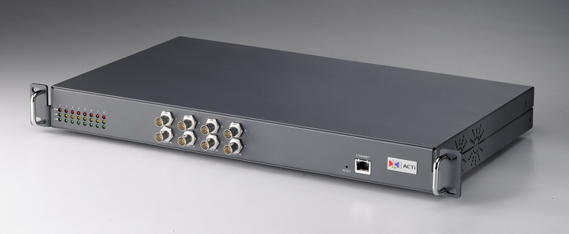

Software CD Terminal Blocks
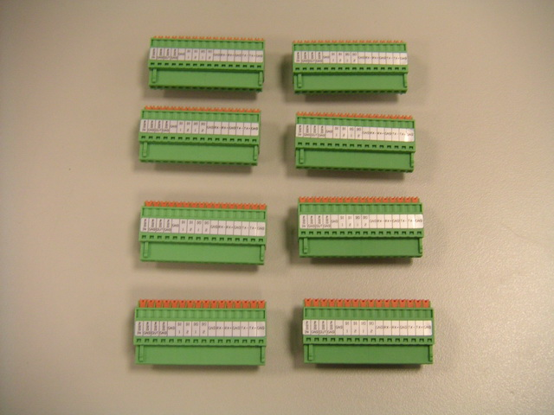

Power Cord Bracket
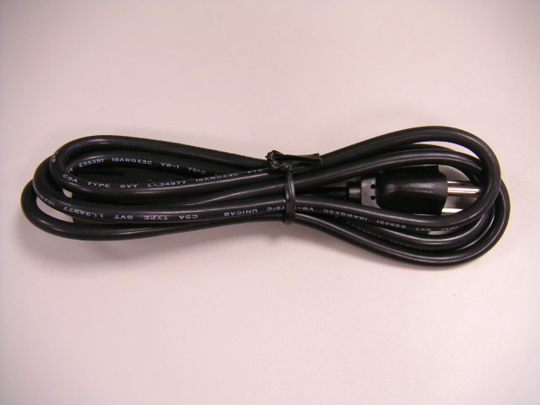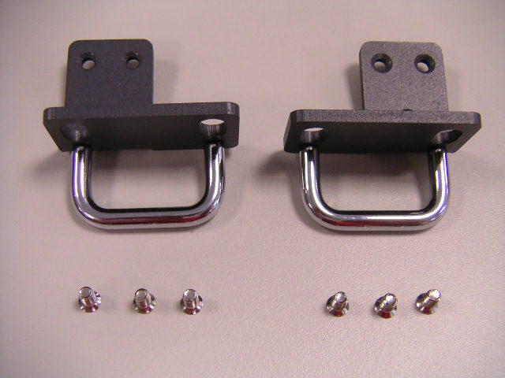

1.2 PHYSICAL DESCRIPTION
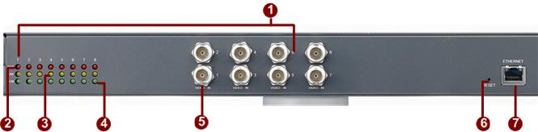

- Channel Number
- Action LED Indicator
The LED will light up after this video channel has successfully completed the boot process.
- LAN LED Indicator
The LEDs indicating when this video channel is transmitting data.
- Serial Port LED Indicator
LEDs indicating when serial port is active.
- Video Input
Each channel supports one analog video input of composite signal with BNC connector
- Reset Button
Step 1: Switch off video server by disconnecting the power cable
Step 2: Using a suitable pointed object, press and continue to hold the Reset Button depressed. While continuing to hold the reset button depressed, reconnect the power cable.
Step 3: Keep holding the reset button depressed around 6 seconds, release the reset button. The unit will start up with factory default settings.
- ETHERNET Port
The Video server connects to the Ethernet via a standard RJ45 connector. Supporting NWAY, this Video server can auto detect the speed of local network segment (10Base-T/100Base-TX Ethernet). The Ethernet port is for FTTH and can connect to a xDSL or cable modem
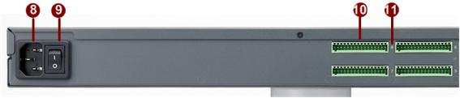

- AC Power Input
100-240V AC 50/60Hz Power Input.
- Power Switch
Video Server power switch.
- Terminal Blocks
The video server supports two alarm input and two alarm output.
DI: Logic Level 0: 0~0.4V; Logic Level 1: 3.3~30V
DO: Logic Level 0: 0.1~0.6V; Logic Level1: 2.4~5V
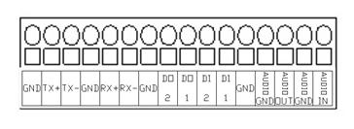
PIN | NAME | DESCRIPTION
PIN | NAME | RS-485 | RS-422 | RS-232*
1 | GND | Ground Pin
2 | Tx+ | D+ | Tx+ | Tx
3 | Tx- | D- | Tx-
4 | GND | Ground Pin
5 | Rx+ |  | Rx+ | Rx
6 | Rx- |  | Rx-
7 | GND | Ground Pin
8 | DO2 | Digital Output 2
9 | DO1 | Digital Output 1
10 | DI2 | Digital Input 2
11 | DI1 | Digital Input 1
12 | GND | Ground Pin
13 | AUDIO GND | Audio Ground Pin
14 | AUDIO OUT | Audio Output
15 | AUDIO GND | Audio Ground Pin
14 | AUDIO IN | Audio Input
* RS-232 mode requires user to set the jumpers inside the video server.
Bcause opening the video server will void the warranty, please contact your distributor for how to switch to RS-232 mode.
- Channel Number

Quick Tour


This section guides you with a quick tour on video server.

2.1 Configure the Video Server
2.1.1 Make sure network environment
Default IP of video server is 192.168.0.100. Please make sure video server and your PC are on the same network segment before running the installation.

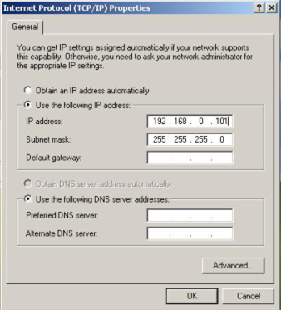
Please set the settings as below.

IP address: 192.168. 0.xxx
Subnet mask: 255.255.255. 0
(NOTE: xxx should be a number from 1 to 254, but 100 is excepted.)

    - Open Internet Explorer with IP address
- STEP1: Open a browser
- STEP2: Enter the IP address of the IP device.
The default IP address is “192.168.0.100”
The “Login Page” is now displayed as below.
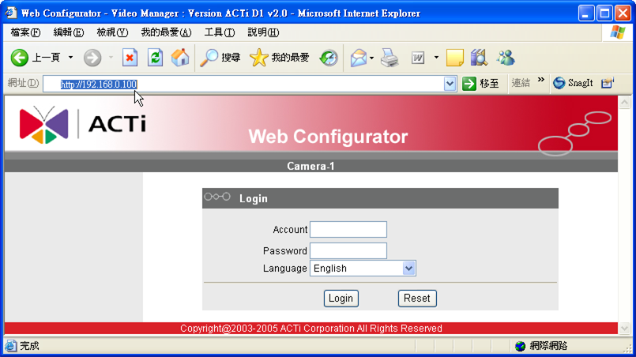
- STEP3: Enter the Account name (factory default: Admin) and the Password (factory default: 123456).
- STEP4: Select the language of the IP device user interface. You can select from English, Traditional Chinese, Simplified Chinese, Japanese, Spanish, Italian, German, Portuguese,Czech and French. This user interface setting will disappear once you log out, if you want to change the default user interface language, please change the setting of [Host setting] after login successed.
 | NOTE: Internet Explorer of 6.0 or above is highly recommended. If you don’t have the it, please download it from http://www.microsoft.com/windows/ie/downloads/default.mspx
- STEP5: Click the button to login or click the button to re-enter again.
Once successfully login, the “Main Setup page” will be displayed as below.
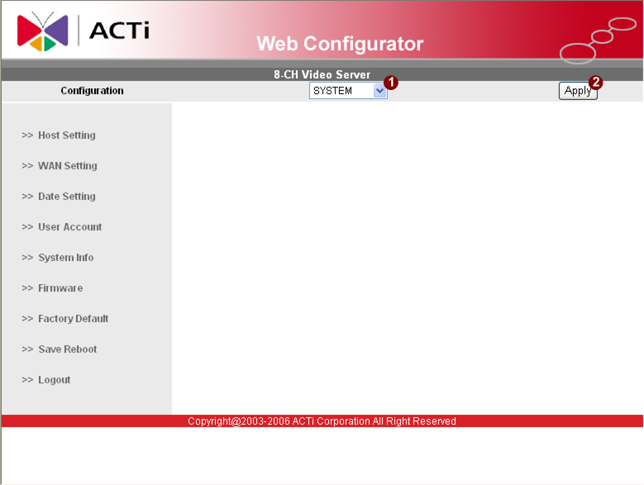
- STEP1: Click to set system configurations of 4-CH Video Server
- STEP2: Click to apply the choice
    - Set New IP
Click the [WAN Setting] on the “Main Setup page”. The “WAN setting page” is displayed as below.
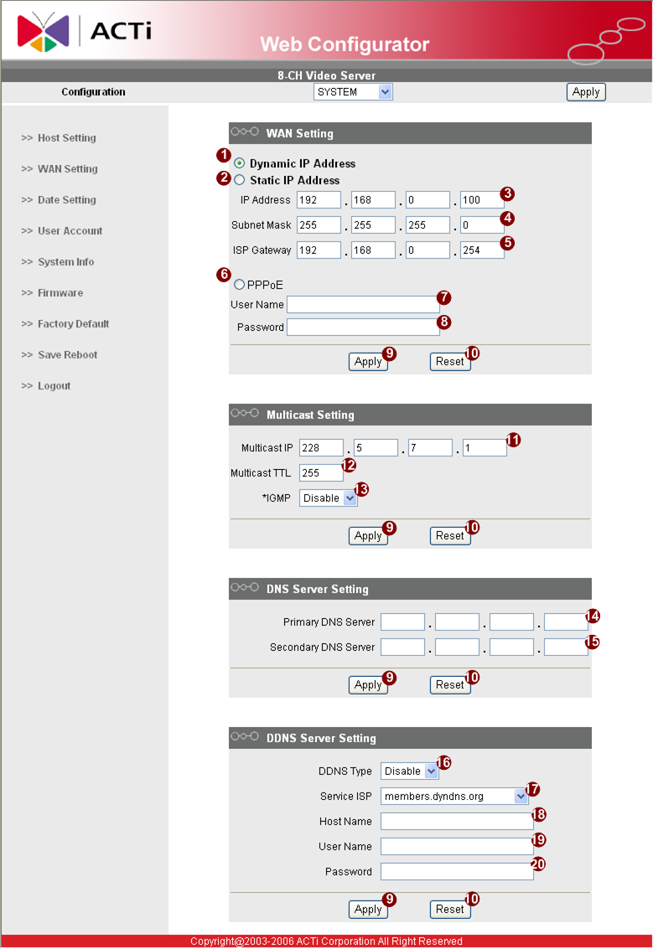

*IP Address : The IP address of the LAN interface. The default IP address is 192.168.0.100.
*Subnet Mask : The subnet mask of the LAN interface.The default subnet mask is 255.255.255.0
*Click button
 | NOTE: Check with your MIS department, if Client PC and IP rugged dome are setting in different VLANs, please connect to WAN port.

NOTE: In your Client PC, please make sure the setting of Network Connections Type is set to Auto Negotation, since IP rugged dome follows MII standard. Otherwise, you might not see the live image.

 | IMPORTANT: After the IP address is changed, please record this IP address. There is no way to connect to the IP rugged dome if user forgets the new IP address.

    - Save Reboot
- STEP1: Click the [Save and reboot] on the “Main Setup page”.
The “Save and reboot page” is displayed as below.
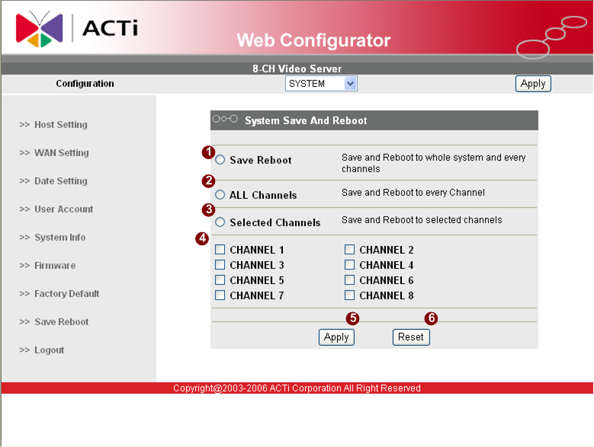
- STEP2: The Action LED indicator will light down to indicate that the IP device is rebooting. After around 30 seconds, the Action LED will light up again to indicate that the reboot is completed.

    - Configuring the IP device – Channel
This section describes how to configure the system part of IP device.
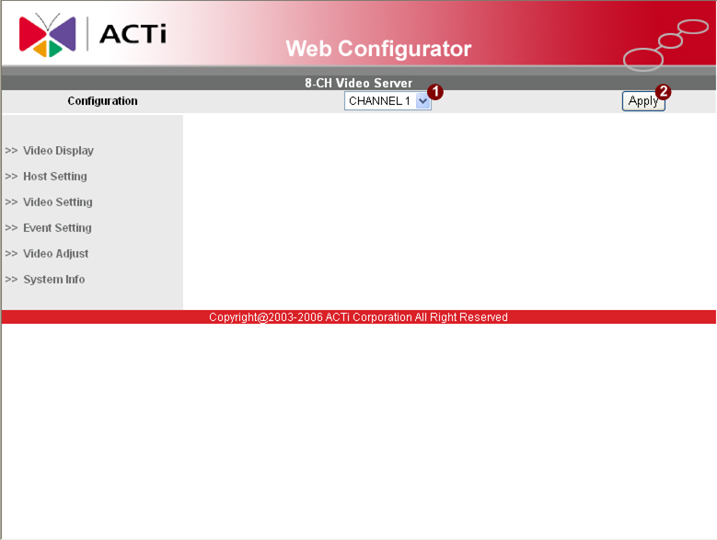
- STEP1: Click to set configurations of every single channel of 4-CH Video Server
- STEP2: Click to apply the choice

    - Preview the video

- STEP1: Click the [Video Display] on the “Main Setup page”.
The “Video Display page” is displayed as below.
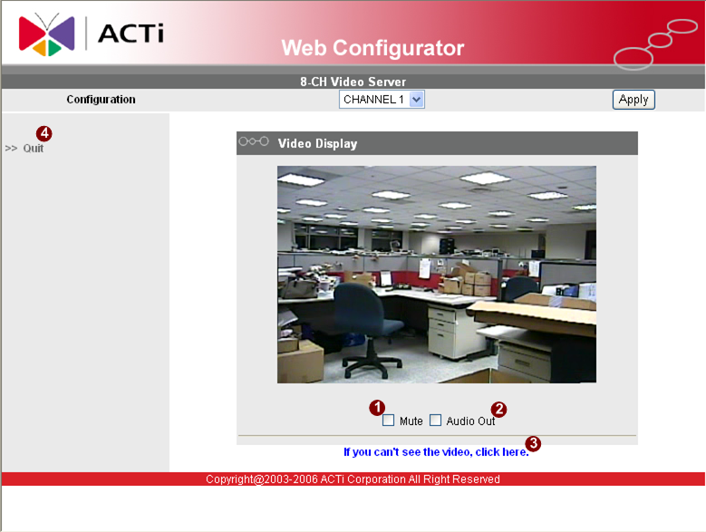
- STEP2: Check the [Mute] checkbox to select mute enable/disable
- STEP3: Click the [Audio Out] checkbox to enable/disable audio output from control PC to IP device.
- STEP4: Click the if you cannot see the video, and follow the instructions.
- STEP5: Click the [Quit] to exit the live view and return to “Main Setup page”.
    - Check Default Video Setting
- STEP1: Click the [Video Setting] on the “Main Setup page”.
The “Video setting page” is displayed as below.
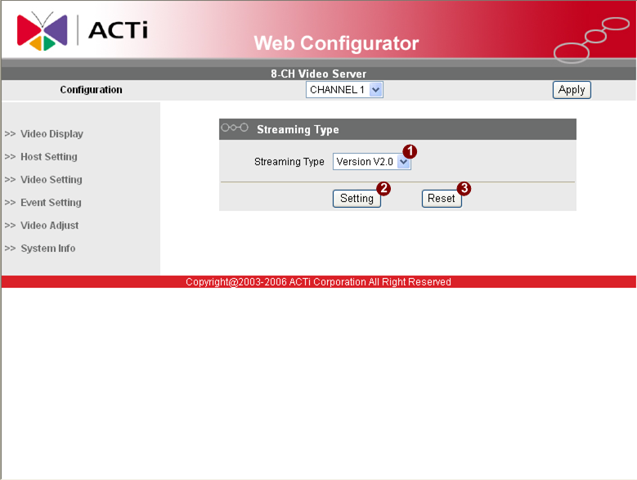

- STEP2: Clieck to enter the configuration table.
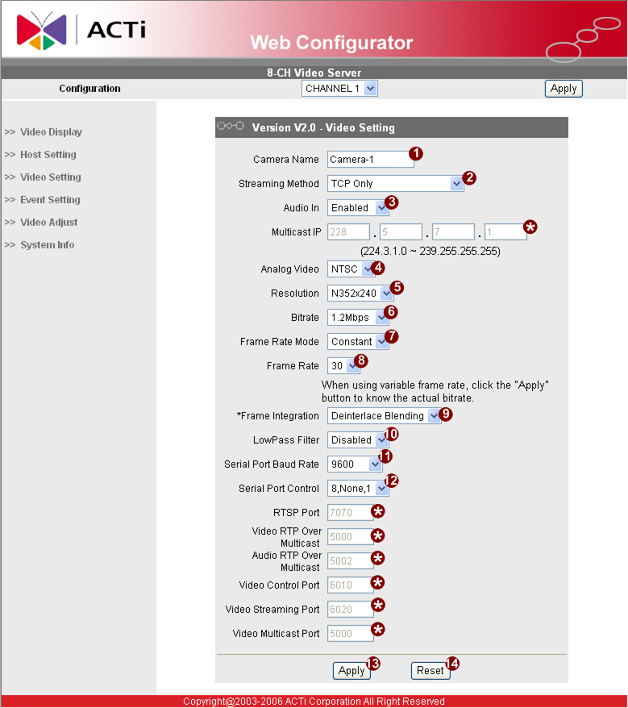
Click the [Apply] button of each setting to confirm the settings or click the [Reset] button to re-enter the parameters.

NOTE: Please make sure the TV Input (NTSC / PAL) is meet your requirement, and click button.

