
Video Decoder
ACD-3100

Ver. 070712

User’s Manual
0

PRECAUTIONS

- Read these instructions
All the safety and operating instructions should be read before the product is operated.
- Heed all warnings
All warnings on the product and in the instruction manual should be adhered to.

The symbol indicates the following items, please carefully read the description next to each symbol.
- Failure to follow the safety instruction given may directly endanger people, cause damage to the system or to other equipment.
- The requirements to make this device work, including hardware, computer settings, network settings, and operation procedures.
- The tips to make using this device easier, more convenient and more efficient.

- Servicing
Do not attempt to service this video product yourself as opening or removing covers may expose you to dangerous voltage or other hazards. Refer all servicing to qualified service personnel.

Trademarks
All names used in this manual for hardware and software are probably registered trademarks of respective companies.

Liability
Every care has been taken during writing this manual. Please inform your local office if you find any inaccuracies or omissions. We cannot be held responsible for any typographical or technical errors and reserve the right to make changes to the product and manuals without prior notice.

FCC/CE Regulation
NOTE: This equipment has been tested and found to comply with the limits for a Class B digital device, pursuant to Part 15 of the FCC Rules. These limits are designed to provide reasonable protection against harmful interference when the equipment is operated in a commercial environment. This equipment generates, uses, and can radiate radio frequency energy and, if not installed and used in accordance with the instruction manual, may cause harmful interference to radio communications.
Operation of this equipment in a residential area is likely to cause harmful interference in which case the user will be required to correct the interference at his own expense.

Table of Contents
0 PRECAUTIONS ii
Trademarks ii
Liability ii
FCC/CE Regulation ii
1 INSTALLATION 1-1
1.1 Package Contents 1-1
1.2 Features and benefits 1-2
1.3 Safety instructions 1-3
1.4 Physical description 1-5
1.5 Mounting the video decoder 1-8
1.6 Basic connections 1-9

INSTALLATION
1

1.1 Package Contents
ACD-3100 Warranty Card
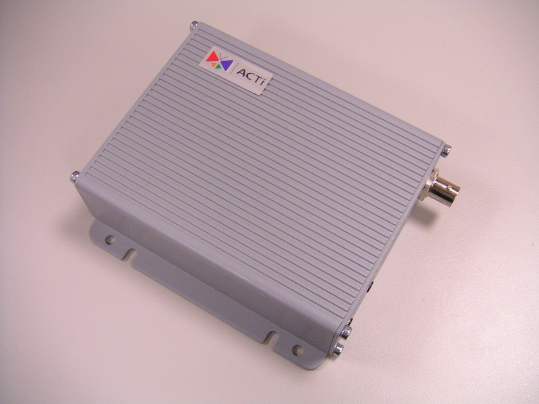

Software CD Terminal Blocks & Screws
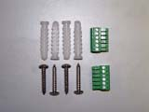

Power Adaptor (Option)
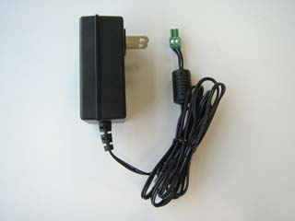

1.2 Features and benefits
The video decoder is a high resolution, Ethernet (LAN and WAN) ready digital video decoder. Via an Ethernet network such as LAN or WAN, the video decoder takes a MPEG-4 stream from our IP camera or video server, and converts it in real-time with high quality analog video signals. This allows analog video devices such as TV system, analog monitors or existing analog video switches to be connected to our IP-base surveillance video system.
- Up to full D1 MPEG-4 video decoding
The video decoder can convert network MPEG-4 stream into analog video signals. It also can automatically detect the remote stream format, resolution and video standards. With ASIC based hardware decoder inside, this video decoder is capable of decoding video at full frame rate (30/25 fps). The analog video resolution of more than 500 TV lines (depends on quality of video source)
- Supports regular TV sysytem and analog monitors
The video decoder does not support composite video only, it also supports Y/C video output. This feature allows analog video devices such as regular TV sets, analog monitors and existing analog video switches to be connected to our IP surveillance video system.
- Digital Time Code Embedded
The “Digital Time Code Embedded” function is to embed the recording time in the MPEG bit stream. Therefore, each image frame has its respective time when it was recorded. It is very useful when users want to find the video at an exact time or between a certain time intervals.
- DDNS Supported
The video decoder supports DDNS (Dynamic Domain Name Server), users can set the video decoder at a virtual domain name (such as cam1.Taipei.xxx) at dynamic IP. Everyone can use the virtual domain name to view the video anywhere that has the access to the internet.
- Bi-directional Audio Supported
The video decoder supports bi-directional audio function, 8kHz Mono audio is provided.

1.3 Safety instructions
- Don’t use the power supply with other voltages
This device is likely to be damaged or damage other equipments / personnel, if you use a power supply with different voltage than the one included with this device. All warranty of this product will be voided in the situations above.
- Don’t open the housing of the product
- Cleaning
Disconnect this video product from the power supply before cleaning.
- Attachments
Do not use attachments not recommended by the video product manufacturer as they may cause hazards.
- Water and Moisture
Do not use this video product near water, for example, near a bathtub, washbowl, kitchen sink, or laundry tub, in a wet basement, or near a swimming pool and the like.
- Don’t use accessories not recommended by the manufacturer
      - Only install this device and the power supply in a dry place protected from weather
      - Servicing
Do not attempt to service this video product yourself as opening or removing covers may expose you to dangerous voltage or other hazards. Refer all servicing to qualified service personnel.
- Damage Requiring service
Disconnect this video product from the power supply immediately and refer servicing to qualified service personnel under the following conditions.
- When the power-supply cord or plug is damaged.
- If liquid has been spilled, or objects have fallen into the video product.
- If the video product has been exposed to rain or water directly.
- If the video product does not operate normally by following the operating instructions in this manual. Adjust only those controls that are covered by the instruction manual as an improper adjustment . Other controls may result in damage and will often require extensive work by a qualified technician to restore the video product to its normal operation.
- Safety Check
Upon completion of any service or repairs to this video product, ask the service technician to perform safety checks to determine that the video product is in proper operating condition.

1.4 Physical description
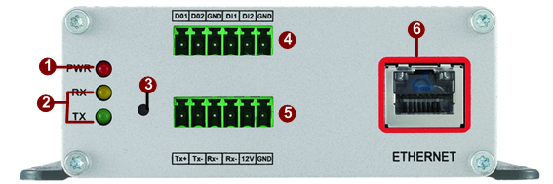

- Action LED Indicator
The LED will light up after IP device has successfully completed the boot process.
- Serial Port LED Indicator
LEDs indicating when serial port is active.
- Reset Button
Step 1: Switch off IP device by disconnecting the power cable
Step 2: Using a suitable pointed object, press and continue to hold the Reset Button depressed. While continuing to hold the reset button depressed, reconnect the power cable.
Step 3: Keep holding the reset button depressed around 6 seconds, release the reset button. The unit will start up with factory default settings.
- Terminal Blocks Pin 1~6
The IP device supports two alarm input and two alarm output. DI: Logic Level 0: 0~0.4V; Logic Level 1: 3.3~30V DO: Logic Level 0: 0.1~0.6V; Logic Level1: 2.4~5V
Please find Support package” TS-00045” for details.

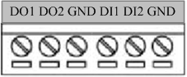

PIN | NAME | DESCRIPTION
1 | DO1 | Digital Output 1
2 | DO2 | Digital Output 2
3 | GND | Ground Pin
4 | DI1 | Digital Input 1
5 | DI2 | Digital Input 2
6 | GND | Ground Pin
- Terminal Blocks Pin 7~12
Pin 7~10: RS232/422/485. Default mode is RS-485
Pin 11~12: DC 12V power input
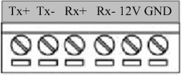

PIN | NAME | DESCRIPTION
PIN | NAME | RS-485 | RS-422 | RS-232
7 | Tx+ | D+ | Tx+ | Tx
8 | Tx- | D- | Tx-
9 | Rx+ |  | Rx+ | Rx
10 | Rx- |  | Rx-
11 | 12V | Power Input (DC +12V)
12 | GND | Ground Pin of Power Input & RS-232
- Ethernet Port
The IP device connects to the Ethernet via a standard RJ45 connector. Supporting NWAY, this IP device can auto detect the speed of local network segment (10Base-T/100Base-TX Ethernet).
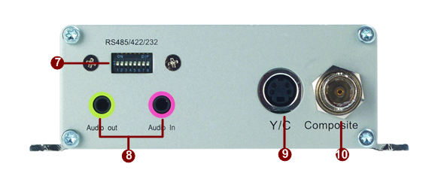
- Dip Switch for Serial Port
RS-485 or RS-422 pin define (default is RS-485)
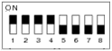
RS-232 pin define
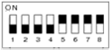
- Audio Input / Output
The IP device supports one audio input and output with earphone jack
- Y/C Output
Analog Video Output of Y/C Signal with S-Video Connector
- Composite Output
Analog Video Output of Composite Signal with BNC Connector

1.5 Mounting the video decoder
The video decoder can be mounted onto a wall by using the accessories provided.

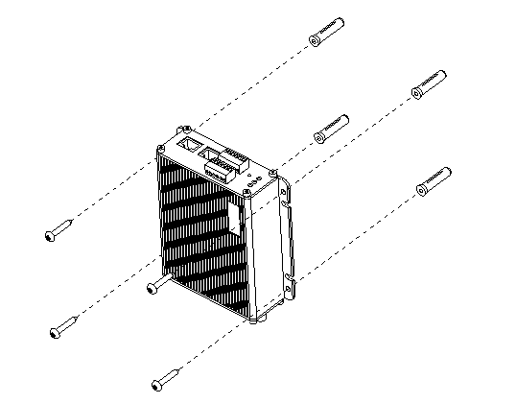

1.6 Basic connections
Follow the procedures below to connect the video decoder to the respective apparatuses.

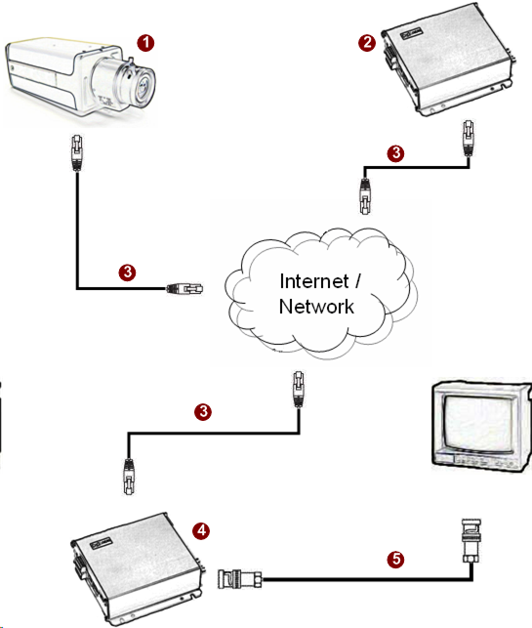

- The IP camera or other encoding devices as a video source
- The video server or other encoding devices as a video source
- Connect video server / IP camera and video decoder to an Ethernet hub (RJ45 connectors)
- Video decoder is the receiver side
- Connect a coaxial cable to TV monitor and display the video which encoded and transferred from video server / IP camera

