
IP Outdoor IR Bullet Camera
(with DC 12V / PoE / AC24V)

ACM-1430 series

Ver. 070709

Quick Installation Guide
1

Getting Started

1.1 PACKAGE CONTENTS
ACM-1430 series Power Adaptor (Option)
(DC12V / PoE / AC24V)
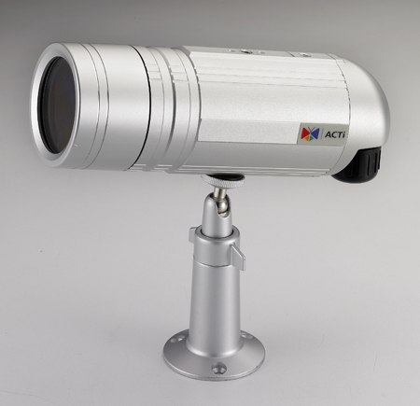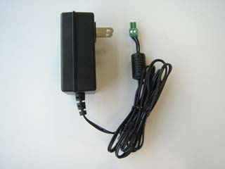

Product CD Terminal Block for Power
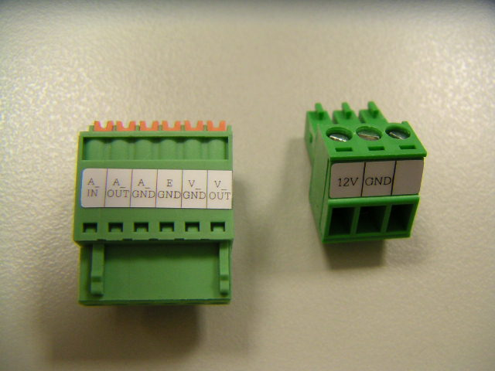

Warranty Card


1.2 PHYSICAL DESCRIPTION
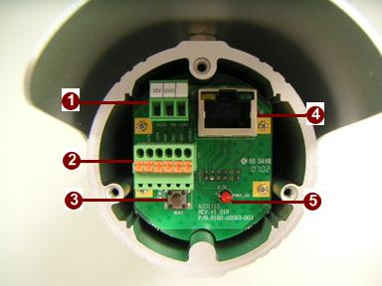

- Power Input
If your power input is DC12V. Please follow the description on the connector to connect to power.
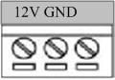
PIN | NAME | DESCRIPTION
1 | 12V | DC Power Input
2 | GND | Ground Pin

If your power input is AC24V. Please follow the description on the connector to connect to power.
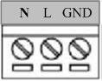
PIN | NAME | DESCRIPTION
1 | N | AC Power Input
2 | L | AC Power Input
3 | GND | E-Ground of power

- Audio Input / Output & Video Output
The IP device supports audio input and output, and video output with terminal block.
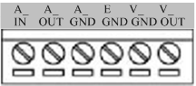
- Reset Button
Step 1: Switch off IP device by disconnecting the power cable
Step 2: Press and continue to hold the Reset Button. Reconnect the power cable while continuing to hold the reset button.
Step 3: Keep holding the reset button depressed for a while, release the reset button. The unit will start up with factory default settings.
- Ethernet Port
The IP device connects to the Ethernet via a standard RJ45 connector. Supporting NWAY, this IP device can auto detect the speed of local network segment (10Base-T/100Base-TX Ethernet).
- Power LED Indicator
The LED indicator lights up one time upon power up. It will lights up again when this IP device is fully booted up.

1.3 BASIC CONNECTIONS
Follow the procedures below to connect the IP device to the respective apparatuses.
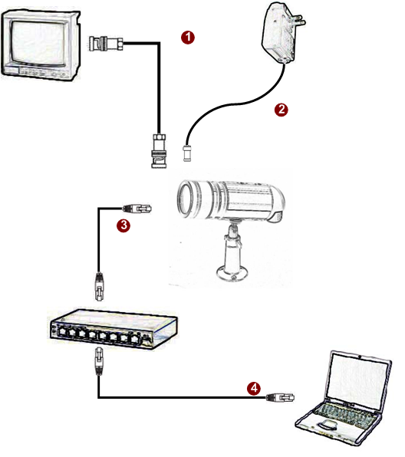

- Connect an analog monitor to IP device video out (BNC connector).
- Connect the power adaptor to IP device
- Connect IP device’s ethernet port to an Ethernet (RJ45 connectors). If your IP device has PoE built-in, you can regard it as a PD and connect it directly to a PSE device like PoE switch.
- Connect a PC to the Ethernet hub (RJ45 connectors)
 | NOTE: You may find a support package for help you getting familiar with PoE. Please visit our web site, and get the support document TS-00040.

1

Installation Procedure

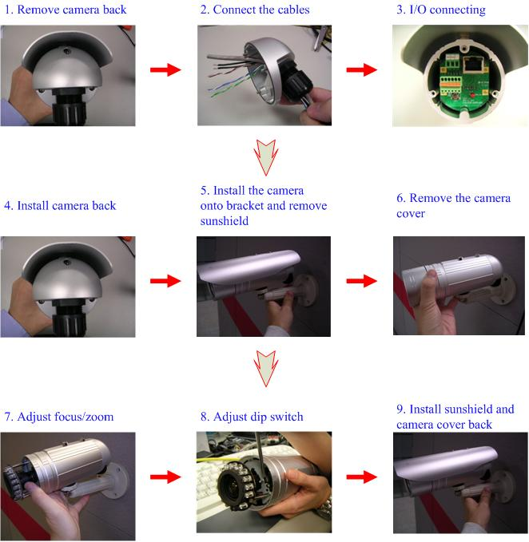

2

Quick Tour

This section guides you with a quick tour on this IP device.

2.1 Configure this IP Device
2.1.1 Make sure network environment
Default IP of this IP device is 192.168.0.100. Please make sure this IP device and your PC are on the same network segment before running the installation.
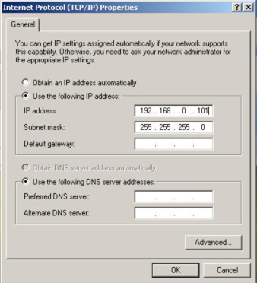
Please set the settings as below.

IP address: 192.168. 0.xxx
Subnet mask: 255.255.255. 0
(NOTE: xxx should be a number from 1 to 254, but 100 is excepted.)
    - Open Internal Explorer with IP address
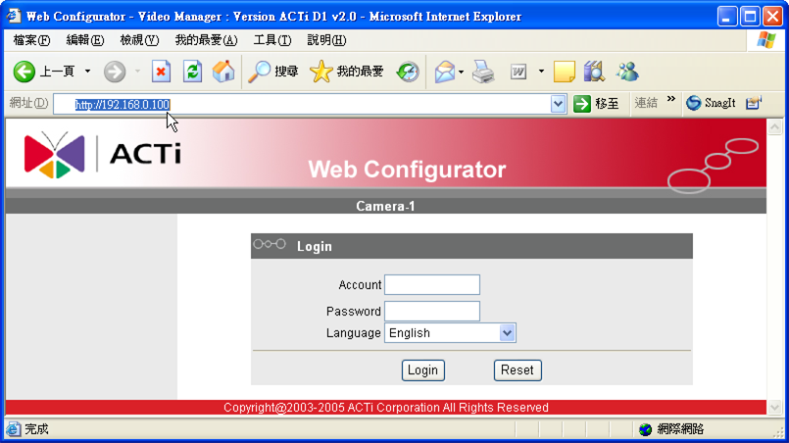

 | NOTE: If your web browser is earlier than IE6, then download IE6 is recommended.
 | NOTE: This IP device default IP address is set to 192.168.0.100

    - Login with default administrator’s account & password
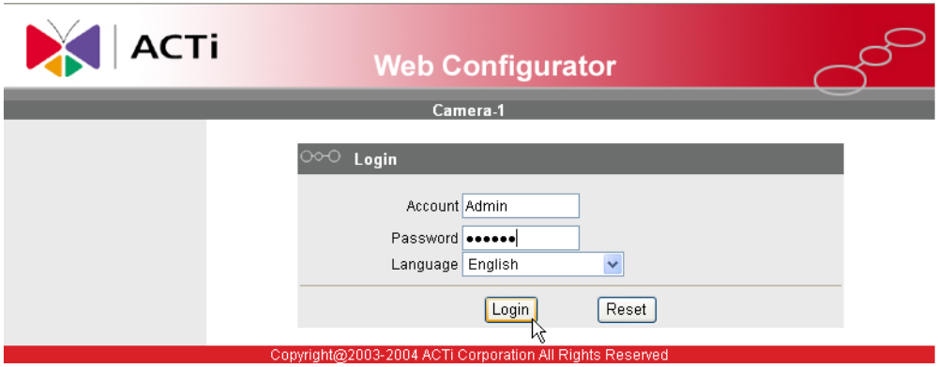

NOTE: Default administrator account is set to Admin, password is set to 123456, and click button.

    - Preview the video

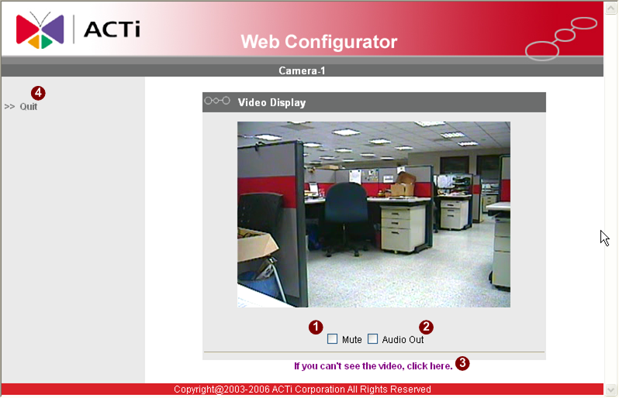

    - Set the new IP address
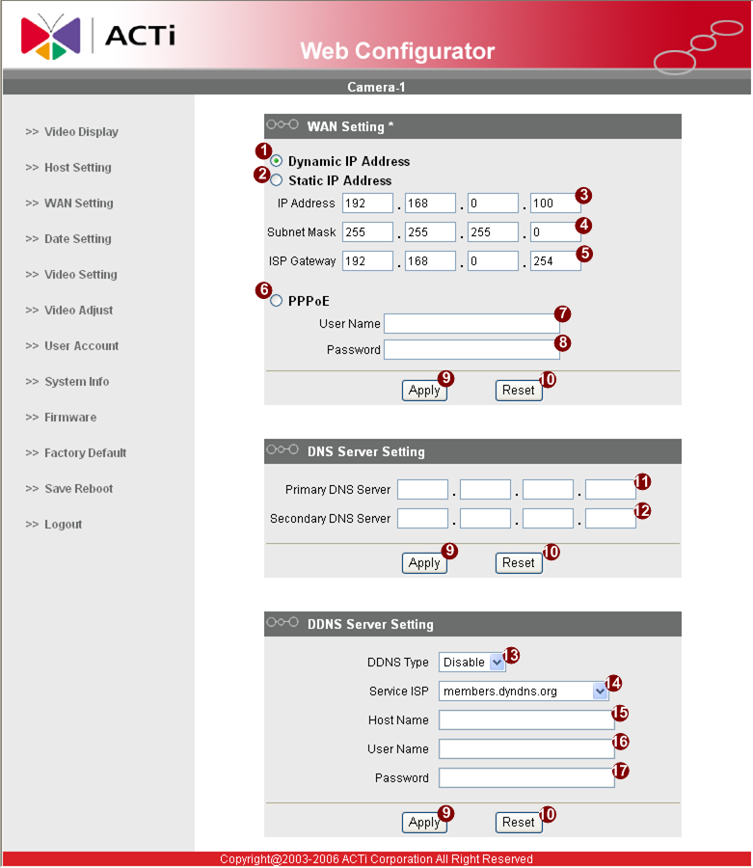
*IP Address : The default IP address is 192.168.0.100.
*Subnet Mask : The default subnet mask is 255.255.255.0
*Click button

 | NOTE: In your Client PC, please make sure the setting of Network Connections Type is set to Auto Negotation, since this IP device follows MII standard. Otherwise, you might not see the live image.
 | IMPORTANT: After the IP address is changed, please record this IP address. There’s no way to connect to the IP device if user forgets the new IP address.

    - Check Default Video Setting
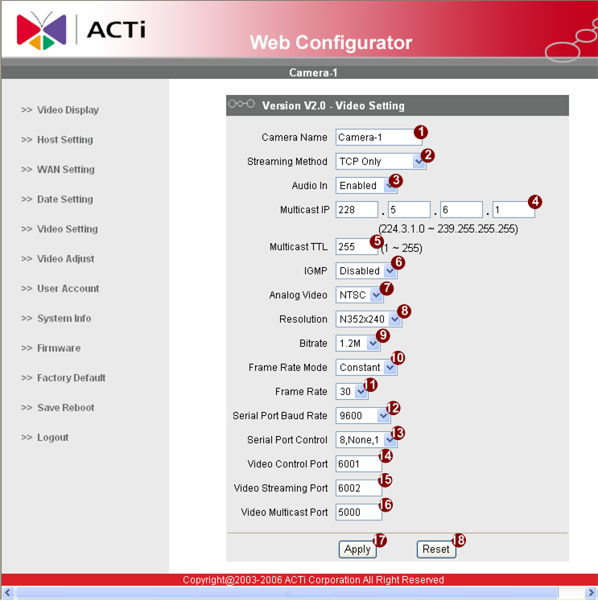

NOTE: Please make sure the TV Input (NTSC / PAL) is meet your requirement, and click button.

    - Click Save Reboot to restore all settings and please wait about 30 seconds for system reboot.

