
MegaPixel IP Outdoor Rugged Dome
(with DC 12V / PoE)

ACM-7411 series

Ver. 080410

Hardware User’s Manual
0
Full D1 CAM-7200 series

CAM-5200

User’s Manual

PRECAUTIONS

- Read these instructions
All the safety and operating instructions should be read before the product is operated.
- Heed all warnings
All warnings on the product and in the instruction manual should be adhered to.

The symbol indicates the following items, please carefully read the description next to each symbol.
- Failure to follow the safety instruction given may directly endanger people, cause damage to the system or to other equipment.
- The requirements to make this device work, including hardware, computer settings, network settings, and operation procedures.
- The tips to make using this device easier, more convenient and more efficient.
- Servicing
Do not attempt to service this video product yourself as opening or removing covers may expose you to dangerous voltage or other hazards. Refer all servicing to qualified service personnel.

Trademarks
All names used in this manual for hardware and software are probably registered trademarks of respective companies.

Liability
Every care has been taken during writing this manual. Please inform your local office if you find any inaccuracies or omissions. We cannot be held responsible for any typographical or technical errors and reserve the right to make changes to the product and manuals without prior notice.

FCC/CE Regulation
NOTE: This equipment has been tested and found to comply with the limits for a Class A digital device, pursuant to Part 15 of the FCC Rules. These limits are designed to provide reasonable protection against harmful interference when the equipment is operated in a commercial environment. This equipment generates, uses, and can radiate radio frequency energy and, if not installed and used in accordance with the instruction manual, may cause harmful interference to radio communications.
Operation of this equipment in a residential area is likely to cause harmful interference in which case the user will be required to correct the interference at his own expense.

Table of Contents
0 PRECAUTIONS 0-1
Trademarks 0-1
Liability 0-1
FCC/CE Regulation 0-1
1 INTRODUCTION 1-1
1.1 Package Contents 1-1
1.2 Features and Benefits 1-2
1.3 Safety Instructions 1-4
1.4 Physical Description 1-6
2 Installation Procedure 2-8
2.1 Connect the IP Outdoor Rugged Dome 2-9
2.1.1 Remove the cover 2-9
2.1.2 Insert the cable 2-9
2.1.3 Connect cables to connectors 2-10
2.2 Mount the IP Outdoor Fixed Dome (Surface) 2-11
2.3 Mount the IP Outdoor Fixed Dome (Flush) 2-12
2.4 Mount the IP Indoor Fixed Dome (Wall) 2-13
2.5 Product Specification 2-14

1

INTRODUCTION

1.1 Package Contents
CAM-7411 series Power Adaptor (Option)
(DC12V / PoE)
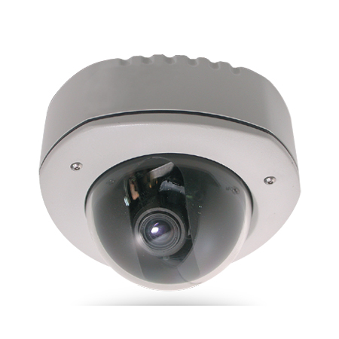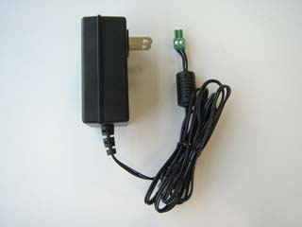

Product CD Terminal Blocks for Power, DI/O & Audio
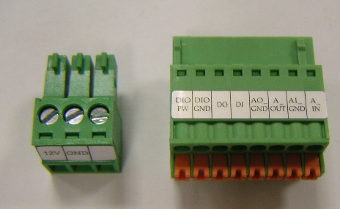

Warranty Card Accessory
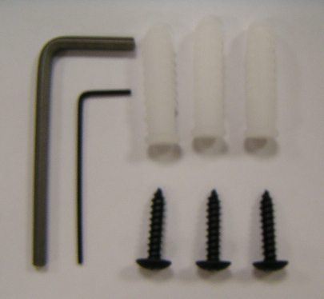

1.2 Features and Benefits
This IP device is a cutting-edge digital video transmission device. It can compress and transmit real time images with outstanding images quality (SXGA, 1280x1024) at reasonable bandwidth through a standard TCP/IP network. That is because it is Ethernet ready and has the powerful ARM9 SoC with excellent system performance to offer dual streams of MPEG4/MJPEG, and both formats offer megapixel resolution. In addition, with these powerful hardware platform, excellent SDK support and powerful respective apparatuses (e.g. the transcoder), this IP device is your best choice building up either conventional IP surveillance system or intelligent IP surveillance system.
- MPEG-4/MJPEG Dual Streaming
With excellent system performance, MPEG-4/MJPEG are supported. It brings superior image quality not only 30 frame per second in full D1 resolution, but also offers up to 7 frames per second in SXGA (1280x1024).
- Automatic Frame Rate Control
This IP device supports automatic/manual streaming frame rate control, especially for multiple clients’ concurrent access the same video stream in different network bandwidth.
- Digital Time Code Embedded
The “Digital Time Code Embedded” function is to embed the recording time in the MPEG bit stream. Therefore, each image frame has its respective time when it was recorded. It is very useful when users want to find the video at an exact time or between a certain time intervals.
- DDNS Supported
This IP device supports DDNS (Dynamic Domain Name Server), users can set this IP device at a virtual domain name (such as cam1.Taipei.xxx) at dynamic IP. Everyone can use the virtual domain name to view the video anywhere that has the access to the internet.
- Build-in Hardware Motion Detection
No more external motion sensors are required. Each IP device can be set up to 3 detection areas. By tuning the object size and sensitivity, it is very reliable to fit into your environment. Besides, hardware motion detection delivers better sensitivity and responds faster than software motion detection.
- Bundle Powerful Surveillance Software
To extend the capabilities of this IP device, a powerful surveillance program is included in the package and is very free to use. Users can easily utilize the existing PC to be a digital video recorder. Schedule recording and manual recording keep every important image recorded in the local hard disk. Reliable and accurate motion detection with instant warning makes you responsive in every condition. Quick and simple search and playback function lets you easily find the images you want.
- Software Development Kit Support
This IP device can be integrated or controlled by user’s application program through the Streaming Library or ActiveX control. With its high level programming interface, software developer’s time and efforts to is highly reduced.

1.3 Safety Instructions
- Don’t use the power supply with other voltages
This device is likely to be damaged or damage other equipments / personnel, if you use a power supply with different voltage than the one included with this device. All warranty of this product will be voided in the situations above.
- Don’t open the housing of the product
- Cleaning
Disconnect this video product from the power supply before cleaning.
- Attachments
Do not use attachments not recommended by the video product manufacturer as they may cause hazards.
- Water and Moisture
Do not use this video product near water, for example, near a bathtub, washbowl, kitchen sink, or laundry tub, in a wet basement, or near a swimming pool and the like.
- Don’t use accessories not recommended by the manufacturer
      - Only install this device and the power supply in a dry place protected from weather
      - Servicing
Do not attempt to service this video product yourself as opening or removing covers may expose you to dangerous voltage or other hazards. Refer all servicing to qualified service personnel.
- Damage Requiring service
Disconnect this video product from the power supply immediately and refer servicing to qualified service personnel under the following conditions.
- When the power-supply cord or plug is damaged.
- If liquid has been spilled, or objects have fallen into the video product.
- If the video product has been exposed to rain or water directly.
- If the video product does not operate normally by following the operating Instructions in this manual. Adjust only those controls that are covered by the instruction manual as an improper adjustment . Other controls may result in damage and will often require extensive work by a qualified technician to restore the video product to its normal operation.
- Safety Check
Upon completion of any service or repairs to this video product, ask the service technician to perform safety checks to determine that the video product is in proper operating condition.

Physical Description

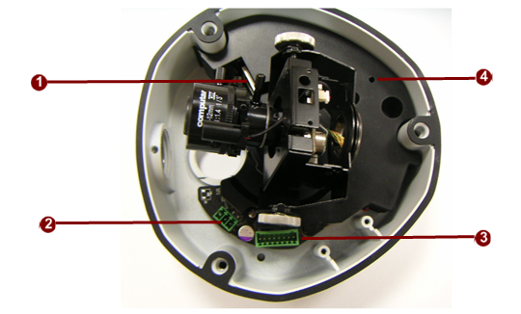

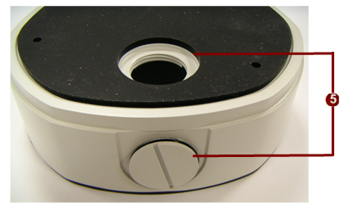

- Ethernet Port
The IP device connects to the Ethernet via a standard RJ45 connector. Supporting NWAY, this IP device can auto detect the speed of local network segment (10Base-T/100Base-TX Ethernet).

- Power Input
If your power input is DC12V. Please follow the description on the connector to connect to power.
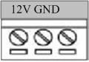
PIN | NAME | DESCRIPTION
1 | 12V | DC Power Input
2 | GND | Ground Pin

Power Input Audio & DIO input/output
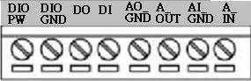

PIN | NAME | DESCRIPTION
1 | DIO PW | DC12VIN
2 | DIO GND | DGND
3 | DO | DO1_TO_OUTSIDE
4 | DI | DI1_FROM_OUTSIDE
5 | AO_GND | DGND
6 | A_OUT | Audio_OUT_LR
7 | AI_GND | DGND
8 | A_IN | Audio_IN

Reset Button
Step 1: Switch off IP device by disconnecting the power cable
Step 2: Press and continue to hold the Reset Button. Reconnect the power cable while continuing to hold the reset button.
Step 3: Keep holding the reset button depressed around 6 seconds, release the reset button. The unit will start up with factory default settings.
Conduit Hole
These conduit holes are used for cables to go through.

2

Installation Procedure

There are three types of installation of this IP outdoor rugged dome series.

 | Surface mount | Flush mount | Wall mount
Pictures |  | 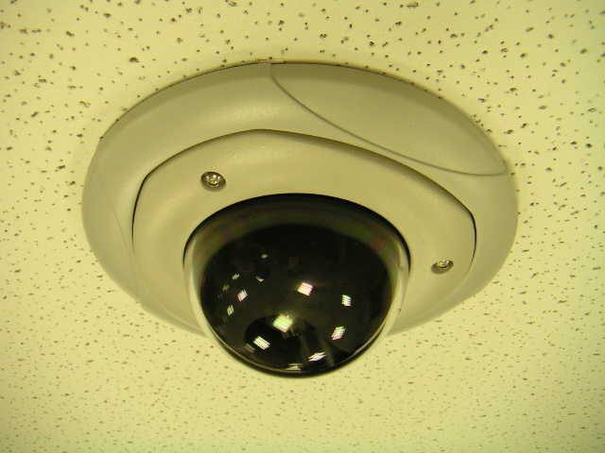 | 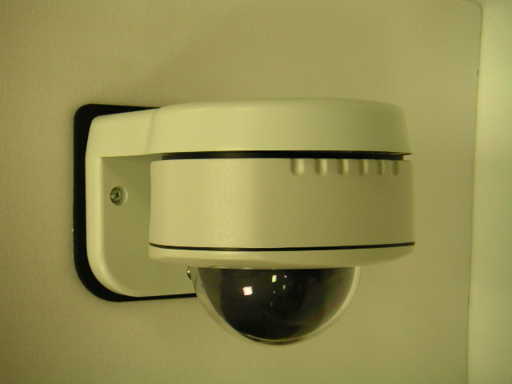
Optional Bracket required |  | ● | ●

The mounting procedure can be divided into two parts,
1st: Connect the IP outdoor rugged dome series
2nd: Mount the IP outdoor rugged dome series

Connect the IP Outdoor Rugged Dome

2.1.1 Remove the cover
Remove the dome cover with special hex wrench in the accessory bag.
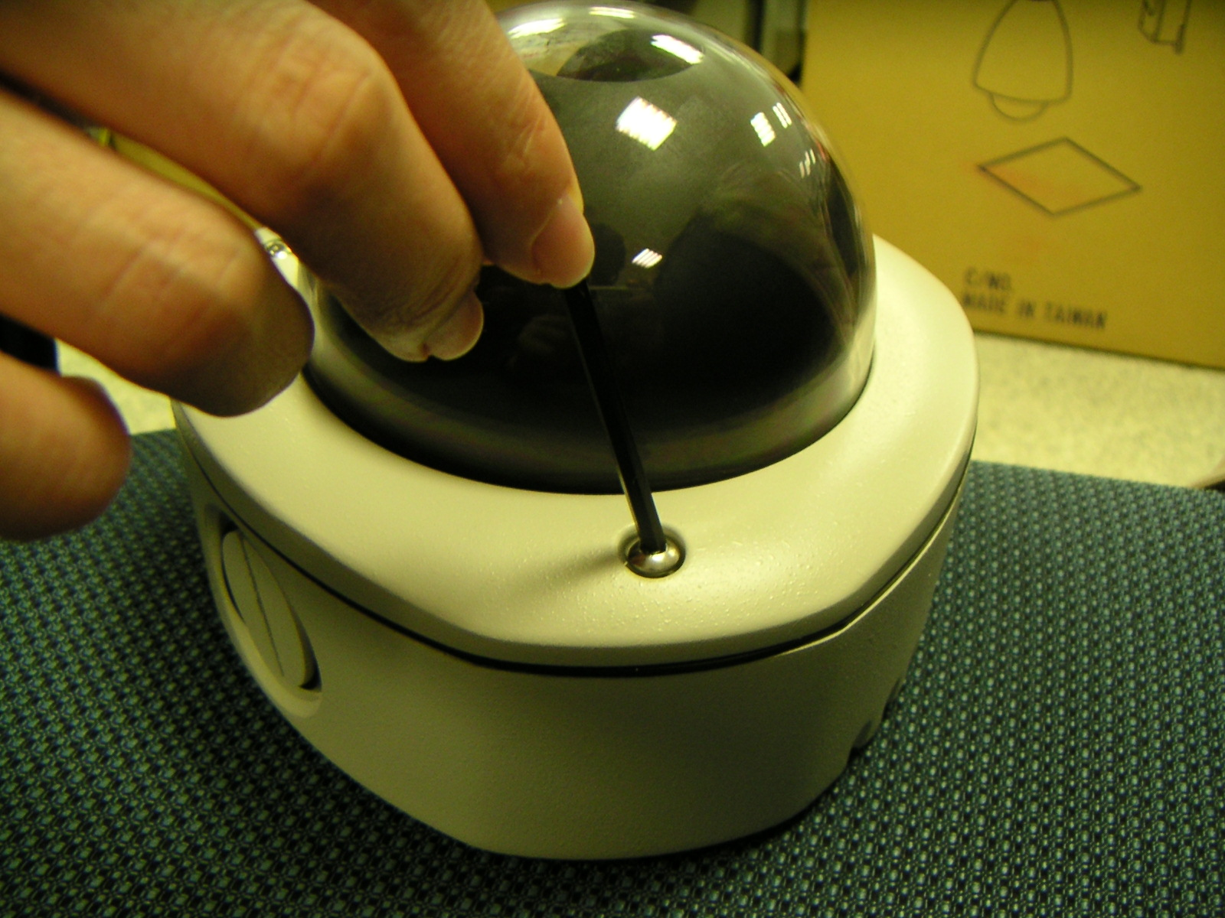

2.1.2 Insert the cable
There are two conduit holes, one is at the dome bottom and the other one is at the side of rugged dome with plug. Remove the plug if your cable will go through the one at the side of rugged dome
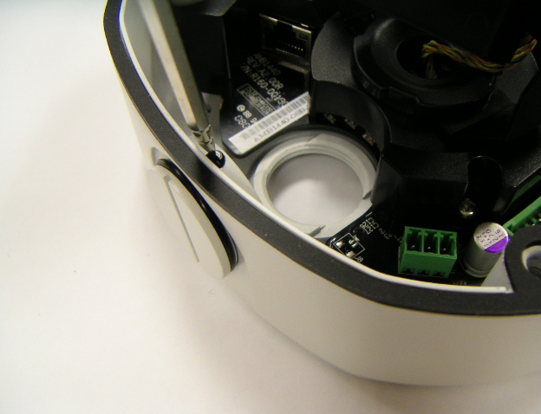

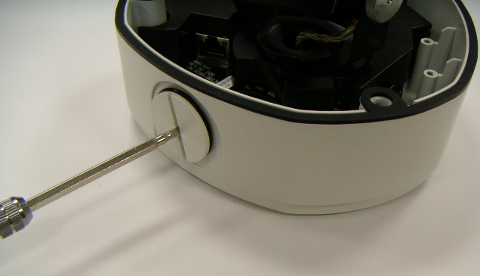

2.1.3 Connect cables to connectors
Please follow the instruction at Chapter 2: Physical Description, for how to connect to each connector.
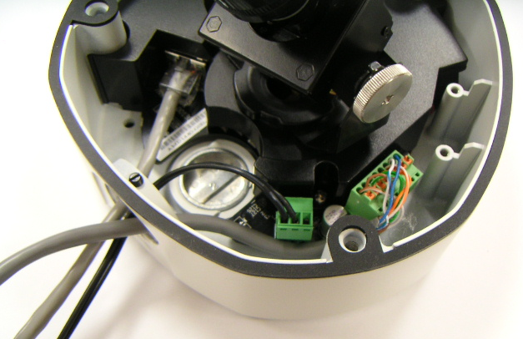

Mount the IP Outdoor Fixed Dome (Surface)
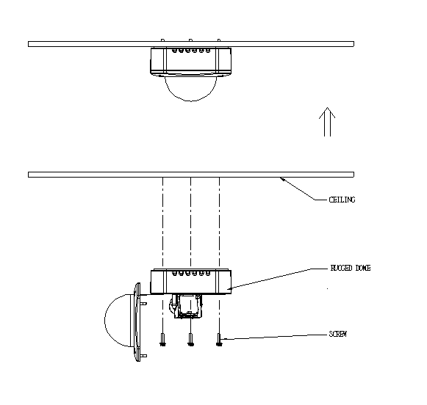

Mount the IP Outdoor Fixed Dome (Flush)
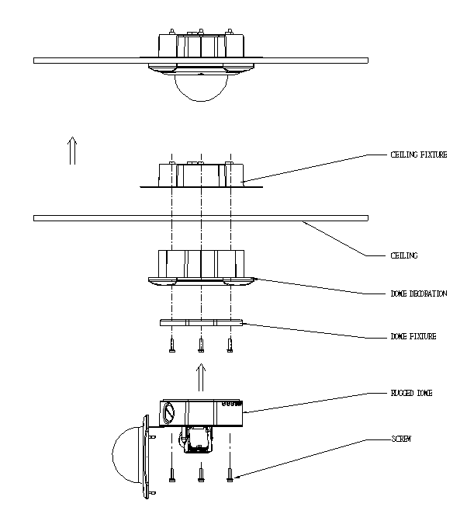

Mount the IP Indoor Fixed Dome (Wall)
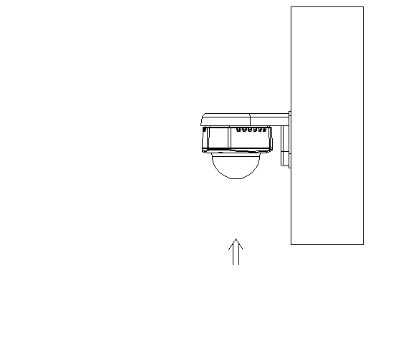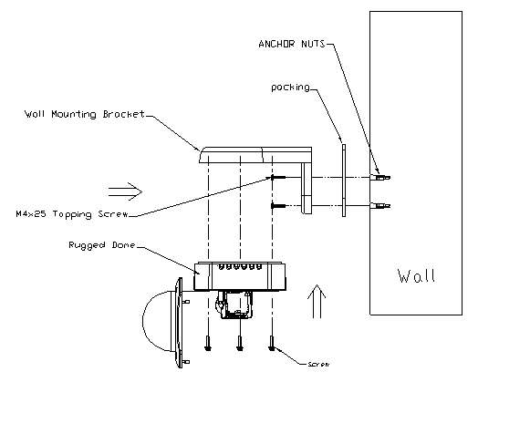

Product Specification



