
IP Indoor High Speed Dome

CAM-6500 series

Ver. 081118

Hardware User’s Manual
0

PRECAUTIONS

- Read these instructions
All the safety and operating instructions should be read before the product is operated.
- Heed all warnings
All warnings on the product and in the instruction manual should be adhered to.

The symbol indicates the following items, please carefully read the description next to each symbol.
- Failure to follow the safety instruction given may directly endanger people, cause damage to the system or to other equipment.
- The requirements to make this device work, including hardware, computer settings, network settings, and operation procedures.
- The tips to make using this device easier, more convenient and more efficient.

- Servicing
Do not attempt to service this video product yourself as opening or removing covers may expose you to dangerous voltage or other hazards. Refer all servicing to qualified service personnel.

Copyright
This manual is the intellectual property of ACTi and is protected by copyright. All rights are reserved. No part of this document maybe reproduced or transmitted for any purpose by any means including electronic or mechanical without the official written permission from ACTi.

Trademarks
All names used in this manual for hardware and software are probably registered trademarks of respective companies.

Liability
Every care has been taken during writing this manual. Please inform your local office if you find any inaccuracies or omissions. We cannot be held responsible for any typographical or technical errors and reserve the right to make changes to the product and manuals without prior notice.

FCC/CE Regulation
NOTE: This equipment has been tested and found to comply with the limits for a Class A digital device, pursuant to Part 15 of the FCC Rules. These limits are designed to provide reasonable protection against harmful interference when the equipment is operated in a commercial environment. This equipment generates, uses, and can radiate radio frequency energy and, if not installed and used in accordance with the instruction manual, may cause harmful interference to radio communications.
Operation of this equipment in a residential area is likely to cause harmful interference in which case the user will be required to correct the interference at his own expense.

Table of Contents
0 PRECAUTIONS 0-1
Copyright 0-1
Trademarks 0-1
Liability 0-1
FCC/CE Regulation 0-2
1 INTRODUCTION 1
1.1 Package Contents 1
1.2 Features and Benefits 2
1.3 Safety Instructions 5
1.4 Physical Description 7
1.5 Mounting the IP High Speed Dome 12
1.6 Basic Connections 13
Appendix A: Speed Dome Installation 14
A-1: Optional Accessories 14
A-2: Ceiling Mount 22
A-3: Surface Ceiling Mounting 23
A-4: Ceiling Panel for In-ceiling Mounting 25
A-5: In-ceiling Mounting 26
A-6: Ceiling Mount with Straight Tube 29
A-7: Wall Mount 30
A-7-1 Wall Mounting with Gooseneck Tble 30
A-7-2 Wall Box Mounting 31
A-8: Corner Mount 32
A-8-1 Corner Standard Mounting Plate 32
A-8-2 Corner Thin/Wide Box Mounting 33
A-9: Pole Mount 34
A-9-1 Pole Thin/Wide Direct Mounting 34
A-9-2 Pole Thin/Wide Box Mounting 35
Appendix B: OSD Menu Notes 36
B-1: OSD Display Format 36
B-2: OSD Setup Menu 36
B-3: Configuration Menu 43
B-3-1 DEFAULT CAMERA 44
B-3-2 BACKLIGHT 44
B-3-3 FOCUS 44
B-3-4 APERTURE 45
B-3-5 AE MODE 46
B-3-6 WBC MODE 48
B-3-7 ID DISPLAY 49
B-3-8 SETUP MENU 49
B-3-9 SETUP MENU2 (18x MODEL Only) 53
B-3-10 TITLE DISPLAY 54
B-3-11 TITLE SETTING 54
B-3-12 ALARM SETTING 55
B-3-13 HOME SETTING 57
B-3-14 SEQENCE 58
B-3-15 AUTOPAN 60
B-3-16 CRUISE 62
B-3-17 IR FUNCTION (Removable IR Cut) 63
B-3-18 ALARM DETECT (18x MODEL Only) 64
B-3-19 WDR SETTING (23x MODEL Only) 65
B-3-20 PRIVACY 66
B-3-21 TIME FUNCTION 69
B-3-22 EXIT OSD 70

1

INTRODUCTION

1.1 Package Contents
CAM-6500 series Warranty Card
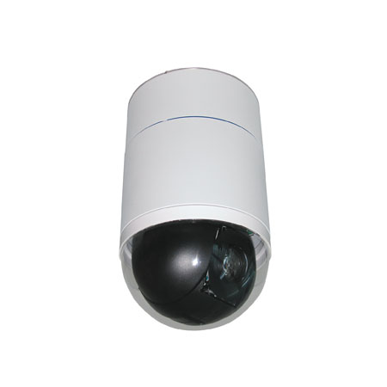

Product CD Power & A/V Cable
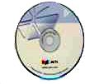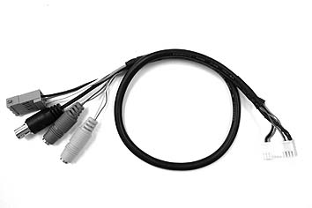

LAN/WAN Cable Power Adaptor (Option)
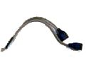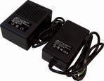

5.4” Transparent Cover Decoration Ring / Fixing Plate

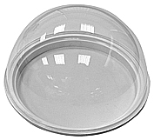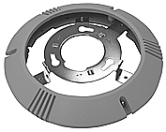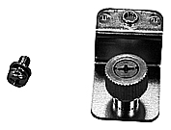

1.2 Features and Benefits
The IP High Speed Dome is designed to deliver superb performance and durability with an intelligent and stylish housing. It also provides a realiable real time images with outstanding image quality (D1, 720x480) at reasonable bandwidth through a standard TCP/IP network. That’s because it is Ethernet (LAN and WAN) ready and has a powerful ARM9 SoC and the MPEG-4 compression ASIC inside. In addition, with these powerful hardware platform, excellent SDK support and powerful respective apparatuses (eg. the transcoder or control keyboards), this IP high speed dome is your best choice building up either conventional IP surveillance system or intelligent IP surveillance system.

The integrated IP high speed dome provides three models:
      - 22x MODEL: 22x optical zoom multiply 12x digital magnifier
      - 18x MODEL: 18x optical zoom multiply 12x digital magnifier/D&N
      - 23x MODEL: 23x optical zoom multiply 12x digital magnifier/D&N/WDR

Precise and Accurate Tracking
Scheduling function, a special feature, enables users to program a preset point or function (Sequence/Auto/Cruise) automatically actions in certain period of time. The IP high speed dome provides vaiable pan/tilt speed ranging from a fast patrol of 400° per second to a slow ramble of 5° per second with 0.225° pan accuracy for fast and accurate tracking ability. The 360° endless rotation and -10°~190° tilt travel makes tracking the object passing directly beneath the dome. Maximum 256 preset points can be programmed for precise location of target areas, and you can also define 8 sequence, 4 auto-pan and 1 cruise rotes for the camera to operate automatically.
Day/Night Features
IR cut filter removable ensures 24 hours operation (18x MODEL/23x MODEL)
Low-Light Application
Digital Slow Shutter and Electronic Shutter functions are provided for clear and high quality image. The minimum illumination is 0.01 Lux.
Perfect Contrast Solution for High Image Quality
Wide Dynamic Range function is a salient features incorporated to fit your needs (23x MODEL)
Privacy Mask for Privacy Protection
There is up to 24 privacy zones of camera view programmable. This is specially designed to avoid any intrusive monitoring at specific region.
Real-time MPEG-4 Compression
With hardware MPEG-4 compression chip inside, the composite video inputs can be efficiently compressed into MPEG-4 bit stream without any delay. The ASIC base compression engine can support not only CIF, but also FULL D1 image resolution.
QoS Enabled Video Streaming
For real-time video streaming requirements, the IP high speed dome implemented the 802.1Q features inside the SoC as the streaming engine to make sure the video streaming package is forwarded faster than normal TCP/UDP packet.
Automatic Frame Rate Control
The IP high speed dome supports automatic/manual streaming frame rate control, especially for multiple clients concurrent access the same video stream in different network bandwidth.
Digital Time Code Embedded
The “Digital Time Code Embedded” function is to embed the recording time in the MPEG bit stream. Therefore, each image frame has its respective time when it was recorded. It is very useful when users want to find the video at an exact time or between a certain time intervals.
Build-in LAN and WAN (Low Latency PPPoE Supported) Ports
The IP high speed dome provides two RJ-45 connectors. One is WAN and the other is LAN. The WAN port connects to the internet and LAN port connects to the local network. Since the internet’s bandwidth is very critical, the WAN port is equipped with a low latency PPPoE (Point-to-Point over Ethernet) which has excellent transmission speed and enables the IP high speed dome to connect to an ADSL or a cable modem.
DDNS Supported
The IP high speed dome supports DDNS (Dynamic Domain Name Server), users can set the IP high speed dome at a virtual domain name (such as cam1.Taipei.xxx) at dynamic IP. Everyone can use the virtual domain name to view the video anywhere that has the access to the internet.
Build-in Hardware Motion Detection
No more external motion sensors are required. Each IP high speed dome can be set up to 3 detection areas. By tuning the object size and sensitivity, it is very reliable to fit into your environment. Besides, hardware motion detection delivers better sensitivity and respond faster than software motion detection.
Bundle Powerful Surveillance Software
To extend the capabilities of the IP high speed dome, a powerful surveillance program is included in the package and is totally free to use. Users can easily utilize the existing PC to be a digital video recorder. Schedule recording and manual recording keep every important image recorded in the local hard disk. Reliable and accurate motion detection with instant warning makes you responsive in every condition. Quick and simple search and playback function lets you easily find the images you want.
Software Development Kit Support
The IP high speed dome can be integrated or controlled by user’s application program through the Streaming Library or ActiveX control. With its high level programming interface, software developer’s time and efforts to is highly reduced.
Dynamic Dome Configuration
Flexible indoor/outdoor mountings. You may find a support package for getting familiar with IP high speed dome’s mounting kits. Please visit our web site, and get the support package document TS-00004.

1.3 Safety Instructions
Don’t use the power supply with other voltages
This device is likely to be damaged or damage other equipments / personnel, if you use a power supply with different voltage than the one included with this device. All warranty of this product will be voided in the situations above.
Don’t open the housing of the product
Cleaning
Disconnect this video product from the power supply before cleaning.
Attachments
Do not use attachments not recommended by the video product manufacturer as they may cause hazards.
Water and Moisture
Do not use this video product near water, for example, near a bathtub, washbowl, kitchen sink, or laundry tub, in a wet basement, or near a swimming pool and the like.
Don’t use accessories not recommended by the manufacturer
      - Only install this device and the power supply in a dry place protected from weather
      - Servicing
Do not attempt to service this video product yourself as opening or removing covers may expose you to dangerous voltage or other hazards. Refer all servicing to qualified service personnel.
Damage Requiring service
Disconnect this video product from the power supply immediately and refer servicing to qualified service personnel under the following conditions.
- When the power-supply cord or plug is damaged.
- If liquid has been spilled, or objects have fallen into the video product.
- If the video product has been exposed to rain or water directly.
- If the video product does not operate normally by following the operating Instructions in this manual. Adjust only those controls that are covered by the instruction manual as an improper adjustment . Other controls may result in damage and will often require extensive work by a qualified technician to restore the video product to its normal operation.
Safety Check
Upon completion of any service or repairs to this video product, ask the service technician to perform safety checks to determine that the video product is in proper operating condition.

1.4 Physical Description
Indoor High Speed Dome Bottom

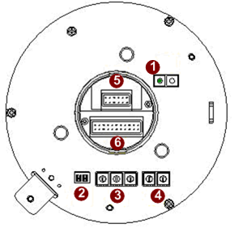

- Reset Button
Step 1: Switch off IP device by disconnecting the power cable
Step 2: Press and continue to hold the Reset Button. Reconnect the power cable while continuing to hold the reset button.
Step 3: Keep holding the reset button depressed around 6 seconds, release the reset button. The unit will start up with factory default settings.
- Communication Switch Setting
The table below shows the function of each pin within the Communication Switch.
Communication Switch | Pin 1 | RS-232 Setting (Reserved)
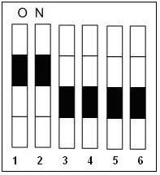 | Pin 2 | RS-232 Setting (Reserved)
 | Pin 3 | Termination
 | Pin 4 | Line Lock
 | Pin 5 | System Initialization (for upgrade)
 | Pin 6 | Reserved
RS-232 is reserved for internal use only; The Pin 3 and Pin 4, they are used for termination and Link Lock adjustment respectively. The Pin 5 is mainly used for return to factory default of camera setting.
- Dome ID Setting
Use the switch to change your speed dome ID by turning the arrow to the desired number respectively. For instance, if the speed dome ID is 123, the ID switch should be set as below:

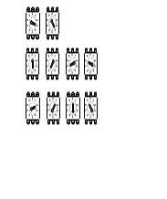
centesimal decimal single digit
NOTE: No two speed domes should be given the same ID, or communication conflict may occur.

NOTE: The number “0” should locate upwards as shown in above diagram for correct switch definition.
do
- Dome Control Protocol
Protocol is a specific set of rules, procdures used for data communications. Basing on the protocol of your management software that you are going to use. Use the switch to set your dome control protocol and the baud rate. Refer to table below and turn the arrow to choose a protocol for your speed dome.
Switch No. | Protocol | Baud Rate
01 | Pelco D | 2400
02 | Pelco P | 4800
07 | DSCP | 9600
11 | Pelco D | 4800
12 | Pelco D | 9600
13 | Pelco P | 2400
14 | Pelco P | 9600
Select protocol: Pelco D, with switch no. 01 and baud rate 2400, for instance, the ID switch should be set as below:
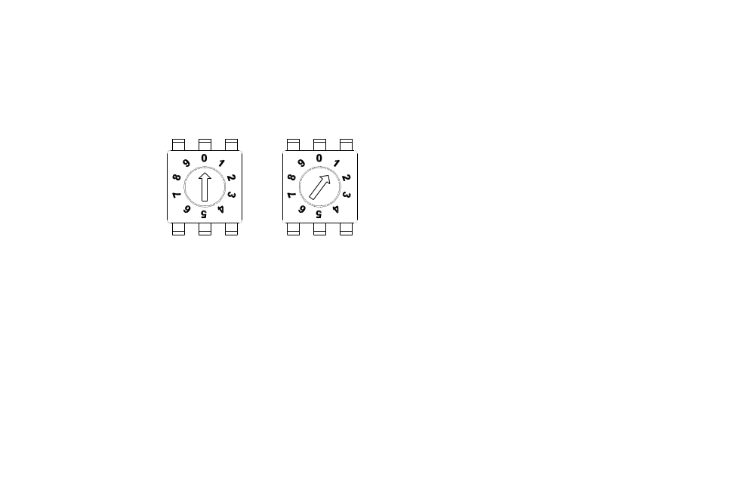
decimal single digit
- 16 Pin Connector for LAN/WAN
The LAN/WAN cable (shown as the figure below) is shipped with IP high speed dome. Please find it in the accessory bag.
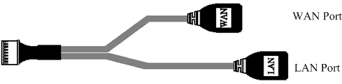
- 22 Pin Connector
A 50cm data cable (shown as the figure below) is shipped with IP high speed dome. Please find it in the accessory bag.
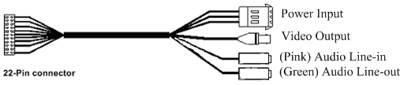
Power Input
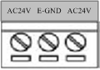
PIN | NAME | DESCRIPTION
1 | AC24V | AC 24V of Power Input
2 | E-GND | E-Ground Pin of Power Input
3 | AC24V | AC 24V of Power Input

      - Cable Wiring
Users may meed to do cable wiring when connecting alarm input and output devices. The table follows will illustrate the way to wire cords into the connector housing(shown in the flgures below).
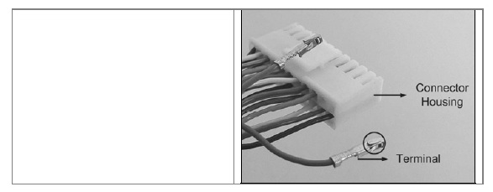
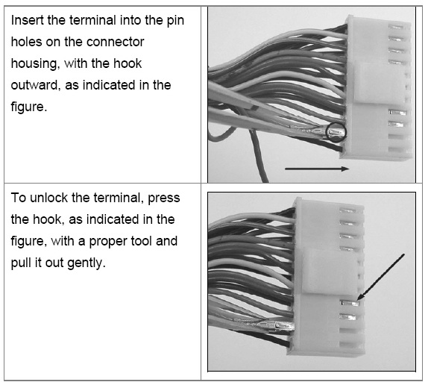

The alarm pins are serviceable for connecting alarm input and output devices, such as alarm sensors, sirens or flashing light with the surveillance system. The table shown as follows lists the definition of alarm pins on the 22-pin connector.
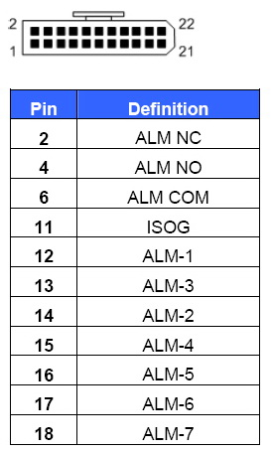

Mounting the IP High Speed Dome
Generally, there are three kinds of ceiling mounting methods: surface mount, in-ceiling mount, and mounting with straight tube. The surface mounting kit is shipped with IP high speed dome. For more detailed information, please refer to Appendix A.

Surface ceiling mount
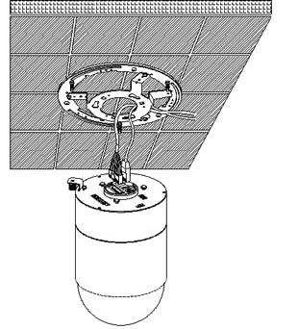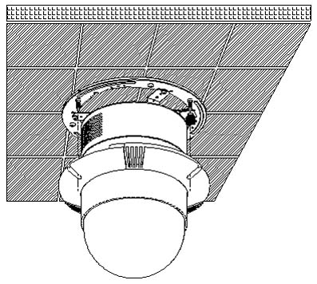
(cables exposed)

Basic Connections

Follow the procedures below to connect the IP high speed dome to the respective apparatuses.
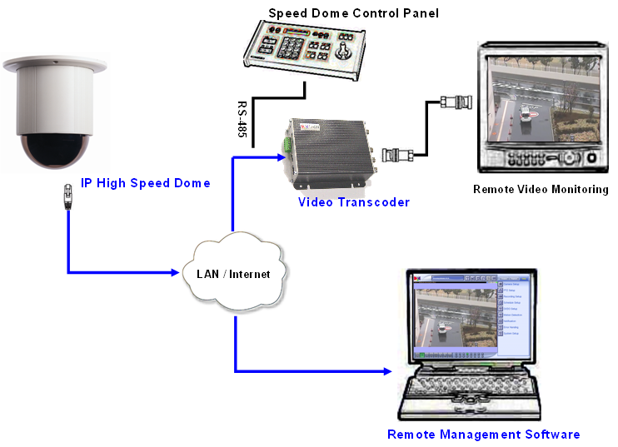

Appendix A: Speed Dome Installation
Basing on user’s installation environments, the dome can be installed on ceiling, on wall or on pole. In the following section, various indoor speed dome installation accessories, installation methods and installation procedures will be described in detail.

A-1: Optional Accessories
Surface Ceiling Mount
For Surface Ceiling use. Height: 21.4mm ; Diameter of the three holes: 4.5mm ; Diameter of the bracket: 158mm
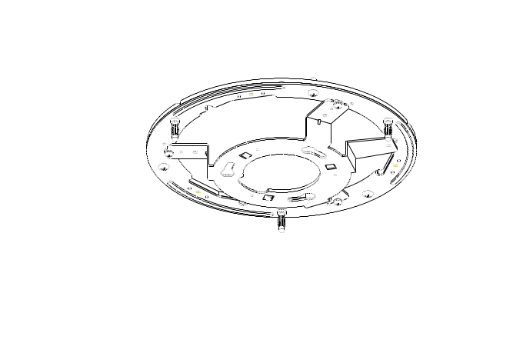 | 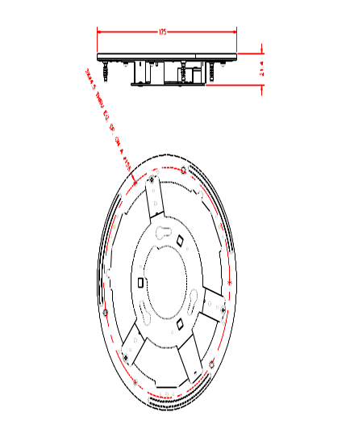
In-Ceiling Mount
For in-ceiling Installation use. Height: 170 mm (6.7 inches); Diameter: 180 mm (7.1 inches); 0.5 kg (1.1 lbs)
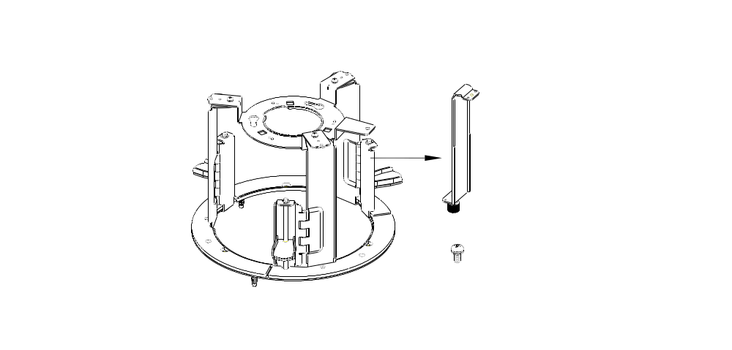 | 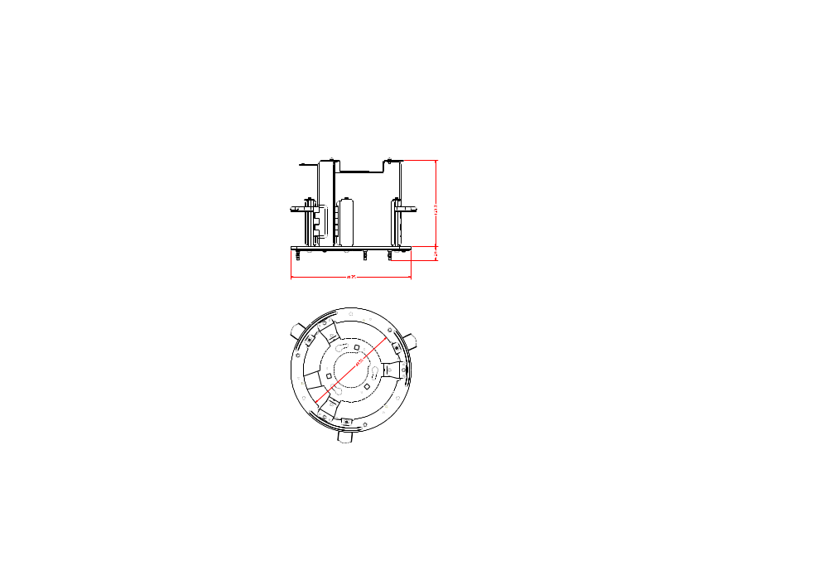
Ceiling Panel
For ceiling mounting. Zn platted; 610×305 mm (24×12 inches); Diameter: 155 mm (6.1 inches)
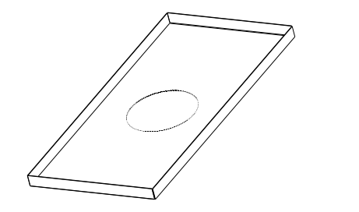

Transparent Cover/Smoke Cover
Diameter: 137 mm (5.4 inches); 127 mm (5.0 inches)
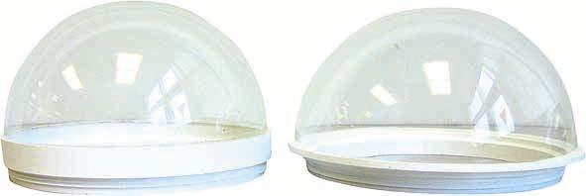
5’’ Transparent Cover 5.4’’ Transparent Cover
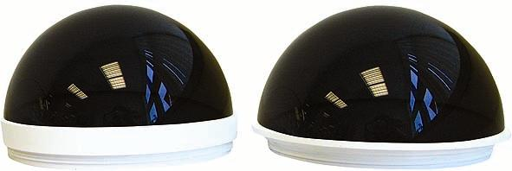
5’’ Smoke Cover 5.4’’ Smoke Cover
Indoor Mount Kit
White; Diameter: 140 mm (5.5 inches); Height: 74 mm (2.9 inches)
For mounting indoor dome camera onto a gooseneck/straight tube.
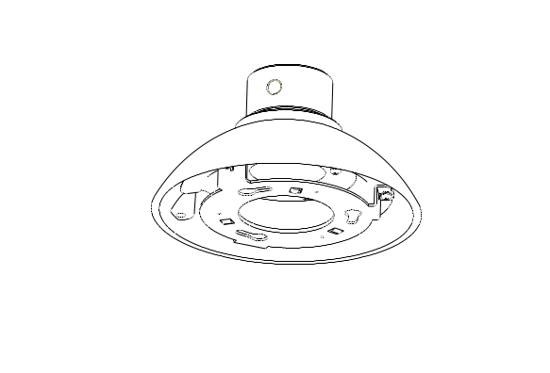

Mounting Accessories
Gooseneck Tube
White/Iron; 298×385 mm (11.73×15.56 inches) ; 2.1 kg (4.6 lbs)
Supplied with rubber washer-8×1, pendant tube washer×1, spring washer-8×1 and waterproof rubber×1, M8*12 screw×1.
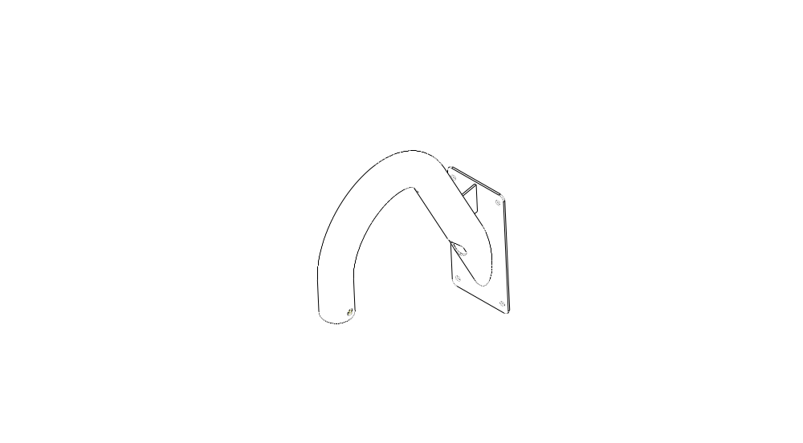 |  | 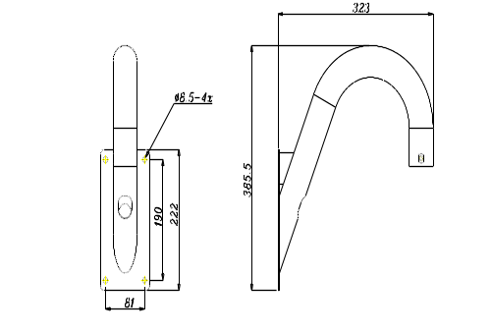
Straight Tube
White/Iron; Height: 250/500 mm (9.8/19.7 inches); Diameter: 50 mm (2 inches)
1 kg (2.2 lbs) / 1.8 kg (4 lbs). Supplied with rubber washer-8×1, pendant tube washer×1, spring washer-8×1 and waterproof rubber×1, M8*12 screw×1.
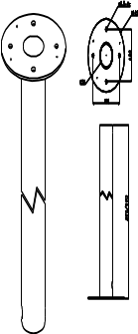 |  | 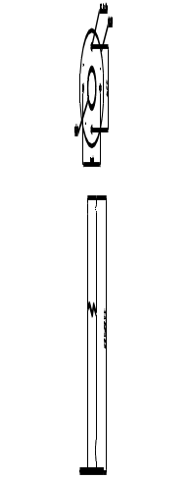
Corner Standard Mounting Plate
White; 222(L)×204(W)×117(D) mm (8.7×8×4.6 inches); 2 kg (4.4 lbs). Supplied with washer-8×4, spring washer×4, M8*20 screw×4, M8 nut×4.
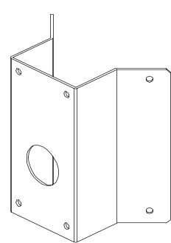 |  | 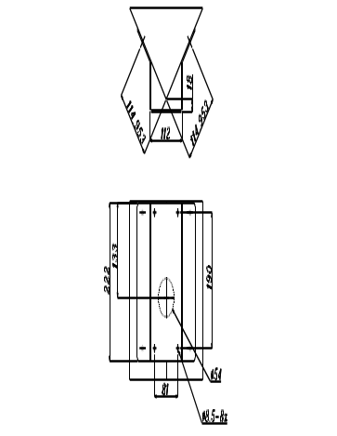
Pole Thin Direct Mounting
White/Ivory; 232(L)×136(W)×60(D) mm (9.1×5.4×2.4 inches); Diameter: 112~140 mm (4.4~5.5 inches); 0.7 kg (1.6 lbs). Supplied with stainless steel straps×4, M8*16 screw×4, washer×4.
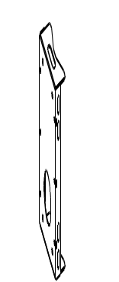 |  | 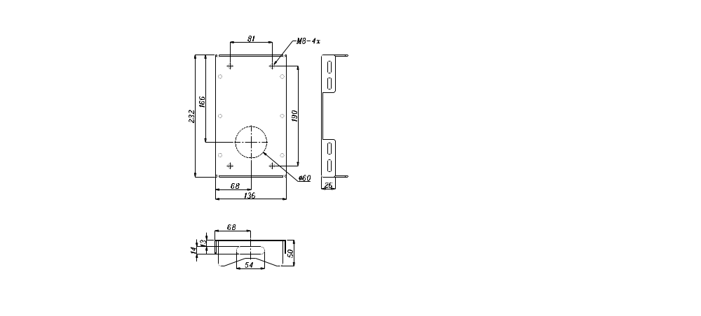
Pole Wide Direct Mounting
White/Ivory; 270(L)×170(W)×60(D) mm (10.6×6.7×2.4 inches); Diameter: 112~130 mm (4.4~5 inches); 1 kg (2.2 lbs). Supplied with stainless steel straps×4, M8*16 screw×4, washer×4, spring washer×4
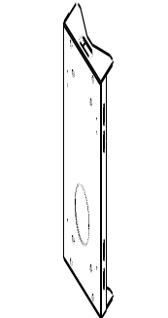 |  | 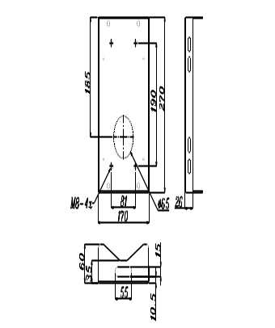
Corner Thin Box
White/Ivory, 300(L)×164(W)×222(D) mm (11.8×6.5×8.7 inches); 3 kg (6.7 lbs); Supplied with washer×4, M8*16 screw×4 and spring washer×4.
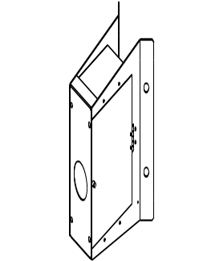 | 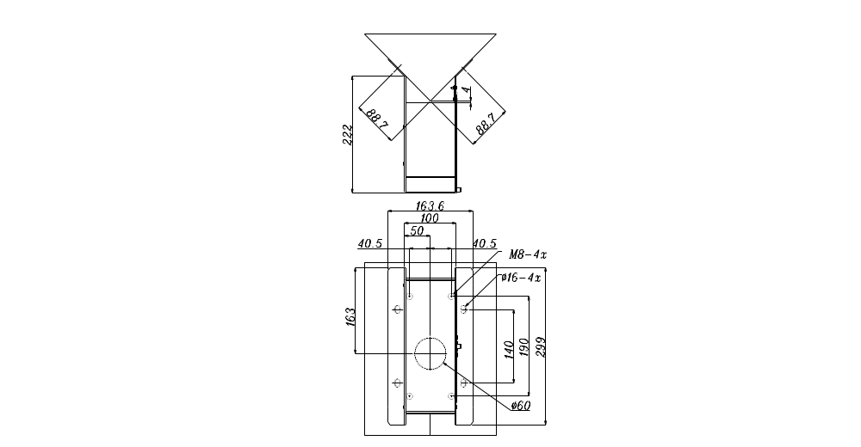
Corner Wide Box
White/Ivory; 232(L)×234(W)×210(D) mm (9.1×9.2×8.3 inches); 2.7 kg (6 lbs); Supplied with washer×4, M8*16 screw×4 and spring washer×4.
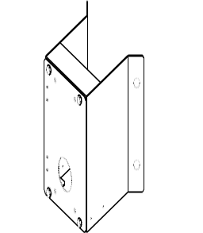 | 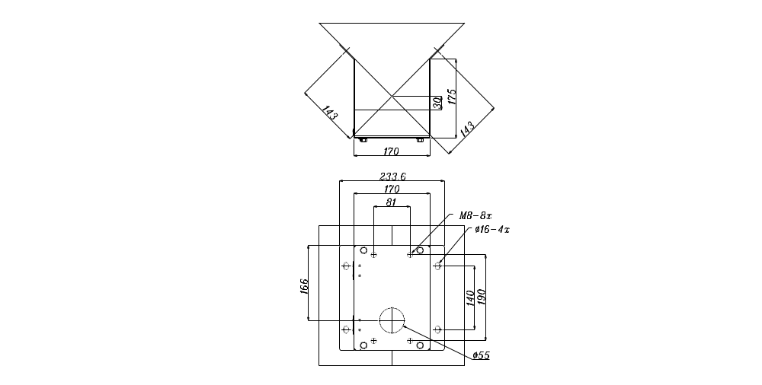
Pole Thin Box
White/Ivory; 291(L)×136(W)×245(D) mm (11.5×5.3×9.5 inches); 3.1 kg (6.9 lbs); Supplied with M8*16 screw×4, washer×4, spring washer×4, stainless steel straps×4.
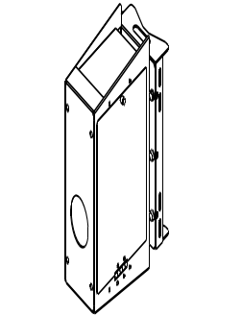 | 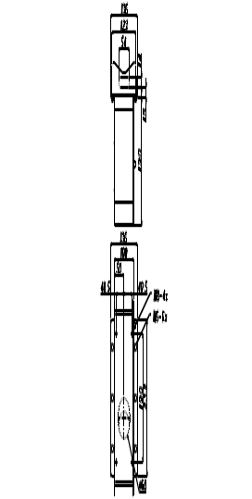
Pole Wide Box
White/Ivory, 270(L)×166(W)×155(D) mm (10.6×6.5×6.1 inches); 3.2 kg (7.1 lbs); Supplied with M8*16 screw×4, washer×4, spring washer×4, stainless steel straps×4.
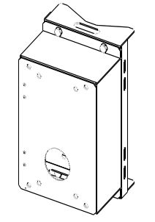 | 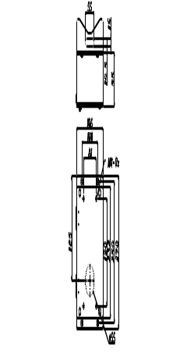
Wall Box Mounting
Ivory, 270(L)×166(W)×95(D) (10.6×6.5×3.7 inches); 2.2 kg (4.84 lbs); Supplied with M8*16 screw×4, washer×4, spring washer×4
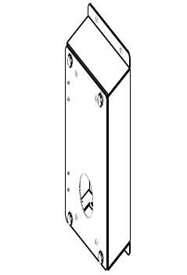 |  | 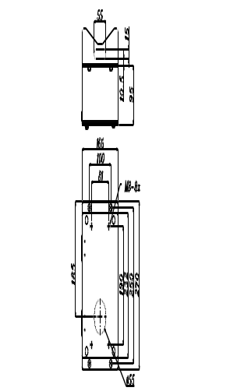
Stainless Steel Straps
For fixing Pole Direct Mounting/ Pole Box on the pole.
Width: 0.63”; 0.02 kg (0.04 lbs)
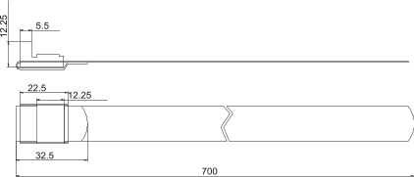
Stainless Strap Cutter
For tension, cut and crimp stainless steel straps. 1.4 kg (3.1 lbs)
Suitable for straps width: 1/2”, 5/8”, 3/4”
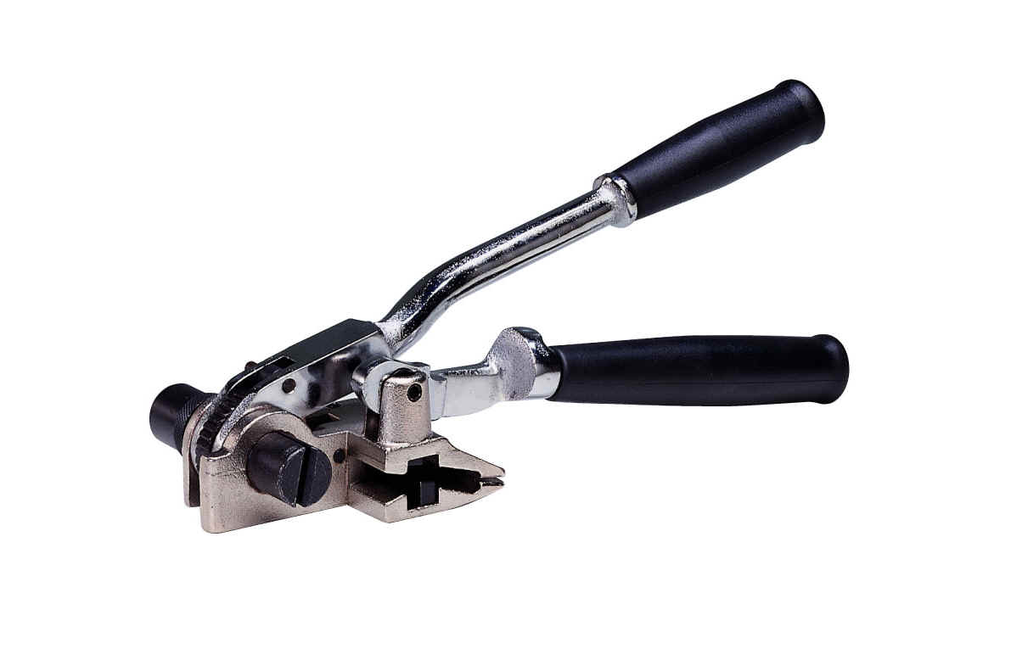

Other Application Accessories
Repeater/Converter
D77R1: RS-485/RS232 Converter
D77R2: RS232 between RS-485/RS-442
D77R3: Bi-phase to RS-485/RS-422
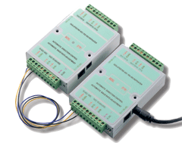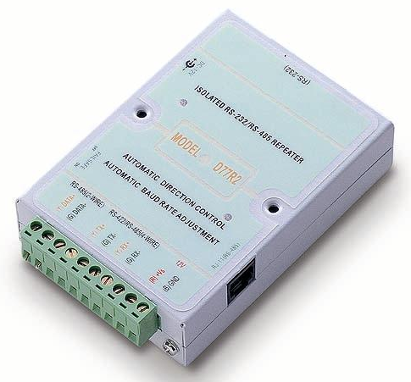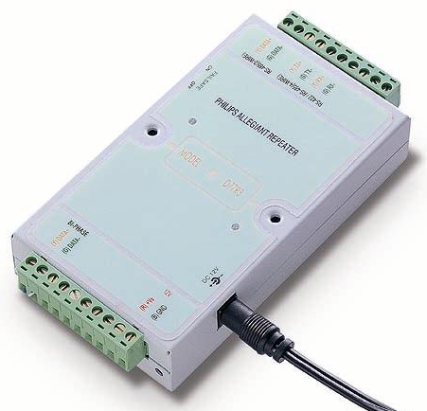
D77R1 D77R2 D77R3
Connector Box (Indoor Application)
Recommended for wiring indoor dome alarm cables. White Color. 92×42 mm (3.7×1.7 inches); 0.13 kg (0.3 lbs); Supplied with cable×1, bracket×1 and M3*6 screw×2.
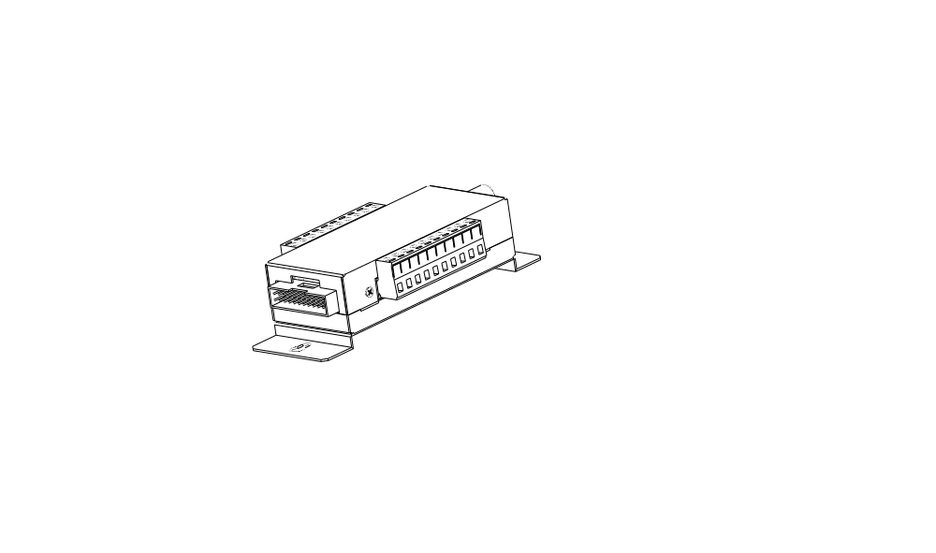
Power Box
White; 186.5×147 mm (7.3×5.8 inches); 2.6 kg (5.8 lbs)
P1030 (Input: 110~115VAC/Output: 24VAC 72VA)
P2030 (Input: 220~230VAC/Output: 24VAC 72VA)
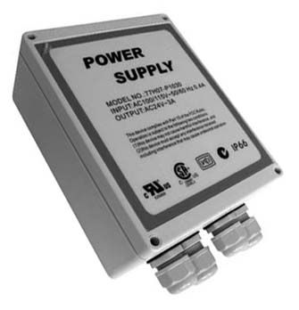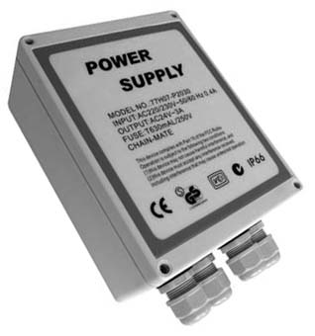
Power Adapter
77H07-A1015 (Input: 100~115VAC/Output: 24VAC 36VA)
77H07-A2015 (Input: 220~230VAC/Output: 24VAC 36VA)
77H07-A1030 (Input: 100~115VAC/ Output: 24VAC 72VA)
77H07-A2030 (Input: 220~230VAC/ Output: 24VAC 72VA)
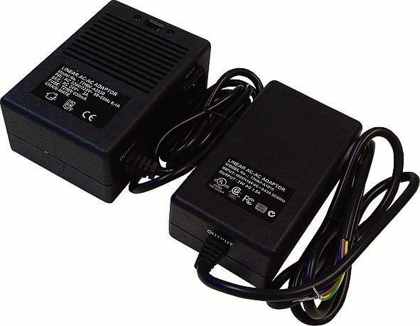

A-2: Ceiling Mount
Generally, there are three kinds of speed dome camera ceiling mounting methods: surface mount, in-ceiling mount, and mounting with straight tube. Refer to the following sections for more detailed information.

The following figures show how cables connect to the speed dome camera in different ways.
Surface ceiling mount
(cables exposed)

In-ceiling mount
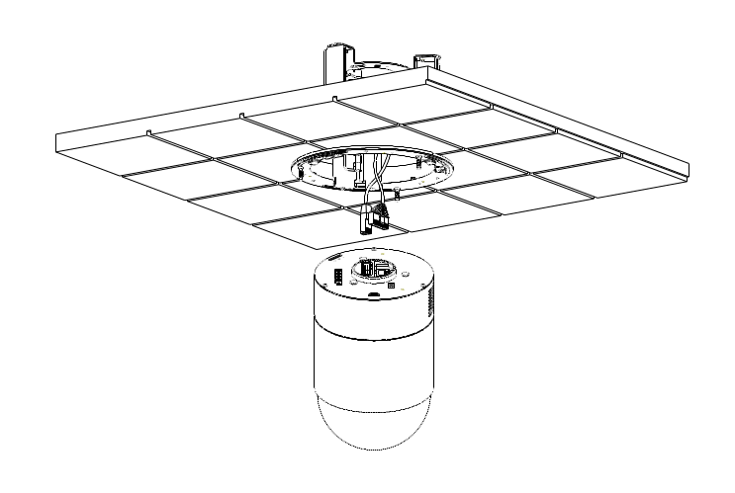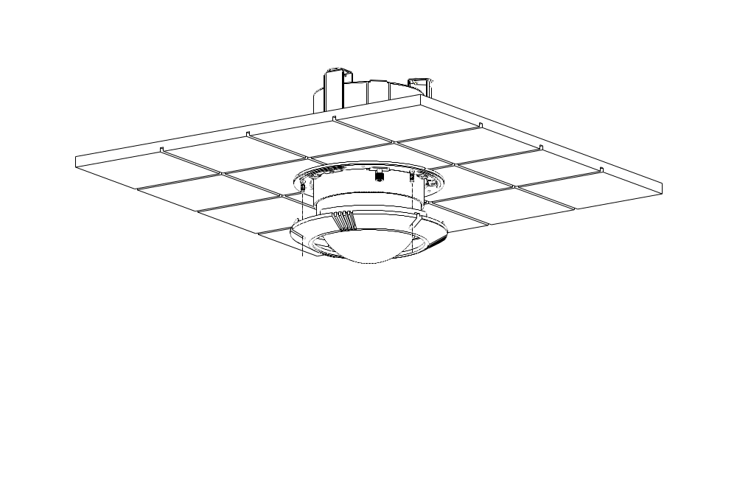
(cables recessed)

A-3: Surface Ceiling Mounting
Surface Ceiling Mounting is a standard installation for an indoor dome, and general mounting accessories are equipped in the standard indoor dome camera package. Here lists the items and tools needed to mount the dome camera onto the ceilings. The supplied items are all in the speed dome camera package.

Items Needed:
- IP High Speed Dome Camera
- Surface Ceiling Mount and Decoration Right
- Fixing Plate

Tools Needed:
- Tool for drilling
- (+,-) Screw Driver

Follow the steps to install the IP high speed dome camera for surface ceilings.
STEP 1  Screw the Fixing Plate to your Dome Body. | 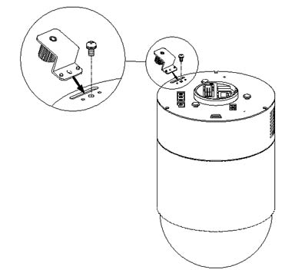
STEP 2  Unpack the dome package and take out the Decoration Ring. Remove the Surface Ceiling Mount from the Decoration Ring. | 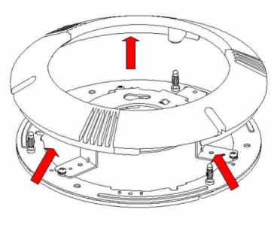
STEP 3  Attach the Mount to the ceiling. Mark the locations where all three ceiling holes should go.  STEP 4  Drill these holes on the surface ceiling. | 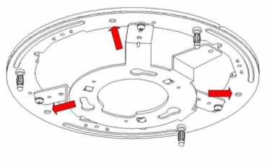
STEP 5  Fix the Mount to the holes on the surface ceiling with three screws. | 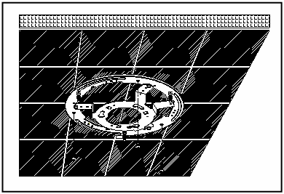
STEP 6
Thread the data cable through the center hole of the Mount and connect the cable to the dome body.

STEP 7  Attach the dome body to the Mount and rotate the dome clockwise. Tighten the fixing screw to fix the dome body. | 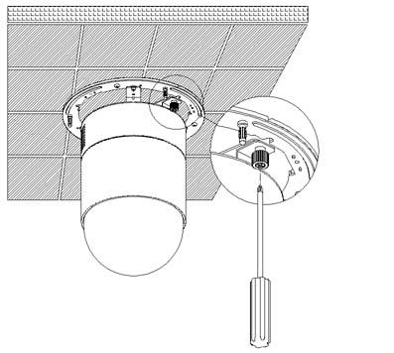
STEP 8
Fix the decoration ring to the bracket and then place the optical cover.

A-4: Ceiling Panel for In-ceiling Mounting
To mount the speed dome camera to a suspended ceiling with the T-Bar, the ceiling panel could be employed, as shown in the figure below.
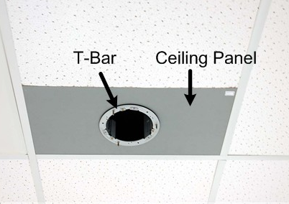
Follow the steps below for installing the ceiling panel.
Step 1: Cut the ceiling half;
Step 2: Put the ceiling panel upward to the ceiling opening;
Step 3: Attach and fasten the T-Bar mount onto the panel (Refer to the next section A-5 In-ceiling Mounting for further details).

A-5: In-ceiling Mounting
Here lists the items and tools needed to mount the dome camera into the ceilings. The supplied items are all in the dome camera package.

Items Needed:
- IP High Speed Dome Camera
- T-Bar (Optional Accessory)
- Supplied Screw (Equipped with T-Bar)
- Red Sticker (Equipped with T-Bar)
- Decoration Ring (Equipped with Surface Ceiling Mount as standard equipment)

Tools Needed:
- Tool for cutting a circle on the ceiling
- (+,-) Screw Driver

Follow the steps to install the integrated high speed dome camera with T-Bar Ceiling mount accessory for in-ceiling mounting.
Step 1:  Disassemble the wing (indicated in the diagram) from the T-Bar Ceiling Mount, and take out the supplied screw in the small bag. | 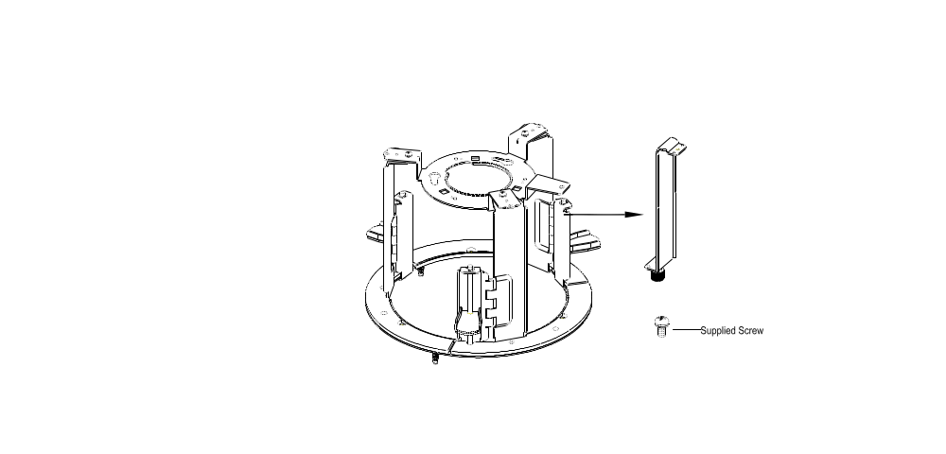
Step 2:  Attach the separated wing to the dome, as shown in the diagram. | 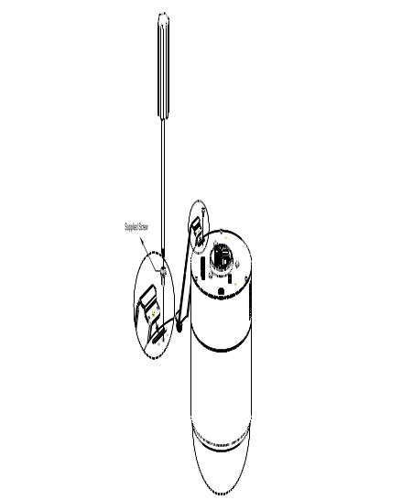
STEP 3  Place the Red Sticker on the ceiling plate, and cut the circle part out of the ceiling. | 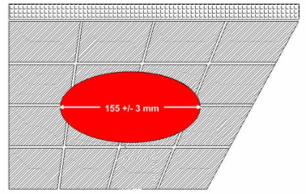
STEP 4  Put up the T-Bar into the ceiling hole. | 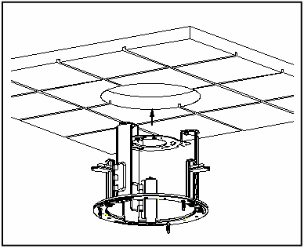
STEP 5  Rotate T-Bar wings of the hinge to fix the T-Bar at the edge of the ceiling hole. | 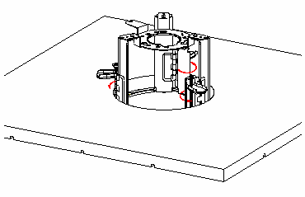
STEP 6  Tighten the screws, and the T-Bar wings will adhere to the ceiling. | 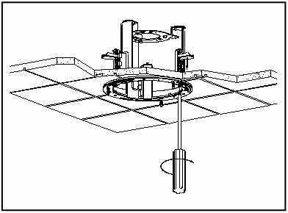
STEP 7
Put the 22-pin data cable through the center hole of the T-bar and connect it to the dome body.
STEP 8  Mount the dome body to the Bracket and rotate it clockwise. Tighten the fixing screw to fix the dome body. | 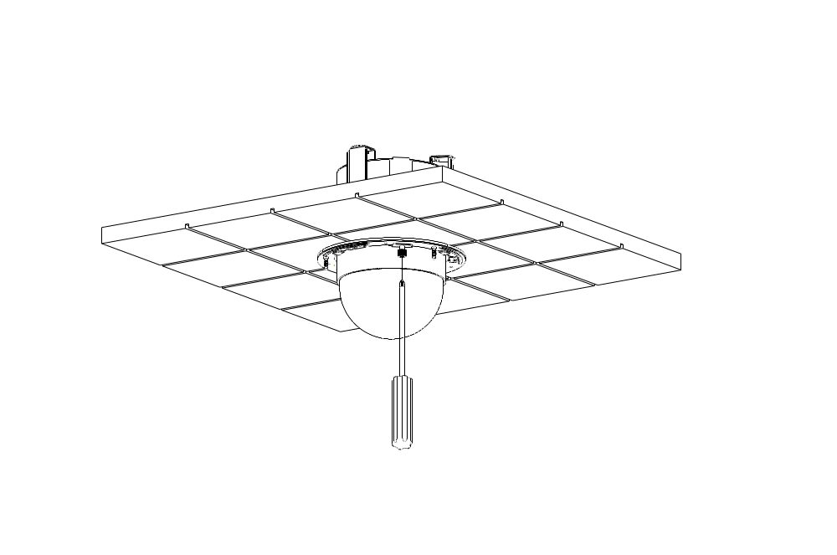
STEP 9
Fix the decoration ring to the bracket and then place the optical cover.

A-6: Ceiling Mount with Straight Tube
The straight tube is available in different length: 25cm and 50cm. Follow the steps to mount the speed with the straight tube.
  - Ensure that the ceiling can support the weight of the speed dome camera and straight tube.
  - Make a cable entry hole on the ceiling
  - Fix the suspension bracket to the ceiling
  - Thread the cables through the straight tube and the Indoor Mount kit and connect them to the speed dome camera
  - Fix the Indoor Mount kit to the straight tube using the screws and washers
  - Attach the dome camera to the Indoor Mounting kit and fix them with the screw

Ceiling Mounting: Straight Tube + Indoor Mount Kit

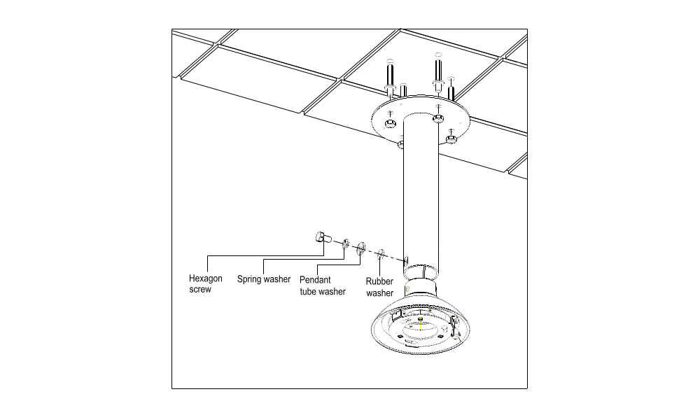

A-7: Wall Mount

A-7-1 Wall Mounting with Gooseneck Tble
The following figures show how cables run through the tube in different ways.

Cables exposed | Cables recessed
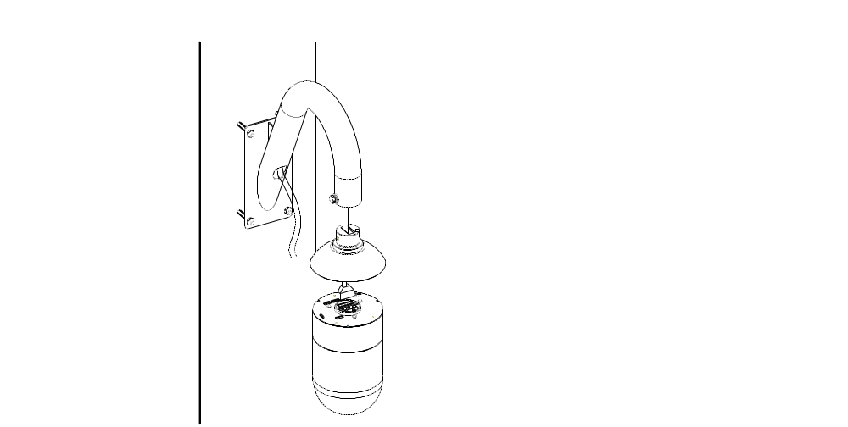 | 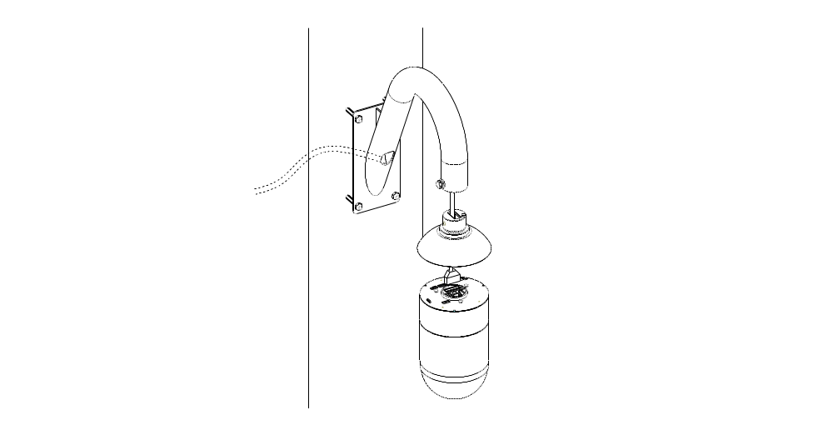

Follow the steps to mount the speed dome with the gooseneck tube.

        - Make a cable entry hole on the wall to recess the cables. Otherwise, cables can be threaded through the cable entry hole on the tube.
        - Fix the suspension bracket on the wall
        - Thread the cables through the gooseneck tube and the Indoor Mount kit and connect them to the dome camera.
        - Fix the Indoor Mount kit to the goosenect tube using the equipped screqs and washers.
        - Attach the speed dome camera to the Indoor Mount kit and fix them with the screw.

Wall Mounting: Gooseneck Tube + Indoor Mount Kit

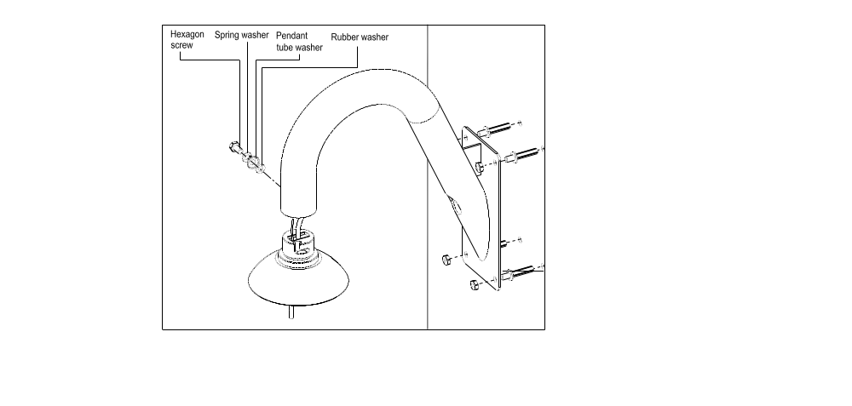

A-7-2 Wall Box Mounting
Follow the steps to mount the dome with the wall box and gooseneck tube.

1) Fix the wall box to wall.
2) Fasten the gooseneck tube on the wall box.
3) Thread the cables through the gooseneck tube and the Indoor Mount Kit and connect them to the dome camera.

For installation of the cables, Indoor Mount kit and the dome camera unit, refer to A-7-1 as the steps are the same as for gooseneck mounting.

Wall Box Mounting: Wall Box + Gooseneck + Indoor Mount Kit
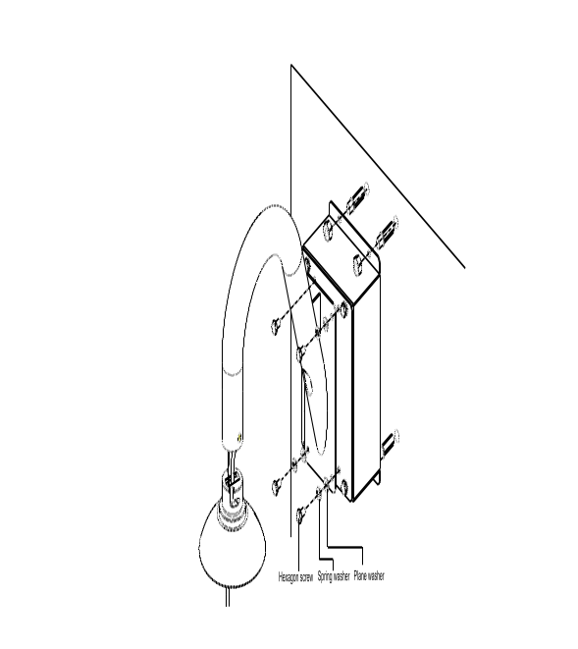

A-8: Corner Mount

A-8-1 Corner Standard Mounting Plate
With the corner mounting plate and gooseneck, the dome can be mounted on wall.
There are various types of corner mounting accessories with different width.

1) Make a cable entry hole on the wall to recess the cables. Otherwise, cables can be threaded through the cable entry hole on the tube
2) Fix the suspension bracket on the wall
3) Attache the gooseneck tube to the firmly fixed bracket
4) For installation of the cables, Indoor Mount kit and the dome unit, refer to section A-7-1 as the steps are the same as for gooseneck mounting.

Corner Wall Mounting: Corner Standard Mounting Plate + Gooseneck Tube + Indoor Mount Kit
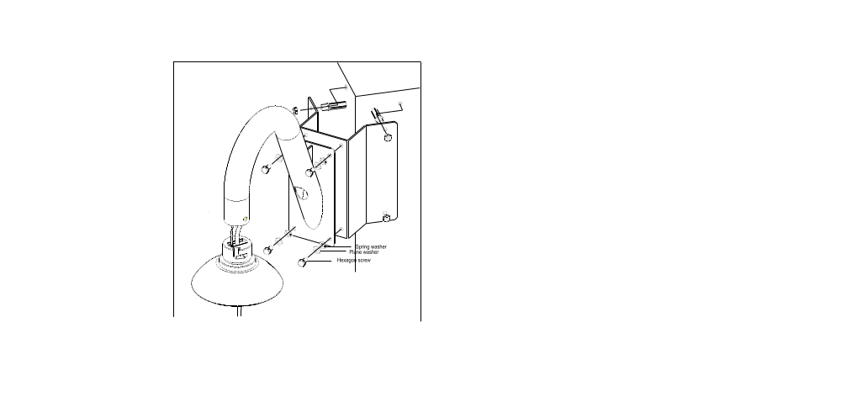

A-8-2 Corner Thin/Wide Box Mounting
The thin/wide corner box is designed to be installed with a gooseneck tube. Follow the steps to mount the dome camera with the corner box and gooseneck tube.

1) Make a cable entry hole on the wall to recess the cables. Otherwise, cables can be threaded through the cable entry hole on the tube
2) Fix the suspension bracket on the wall
3) Attache the gooseneck tube to the firmly fixed bracket
4) For installation of the cables, Indoor Mount kit and the dome unit, refer to section A-7-1 as the steps are the same as for gooseneck mounting.

Corner Box Mounting: Corner Thin/Wide Box + Gooseneck Tube + Indoor Mount Kit
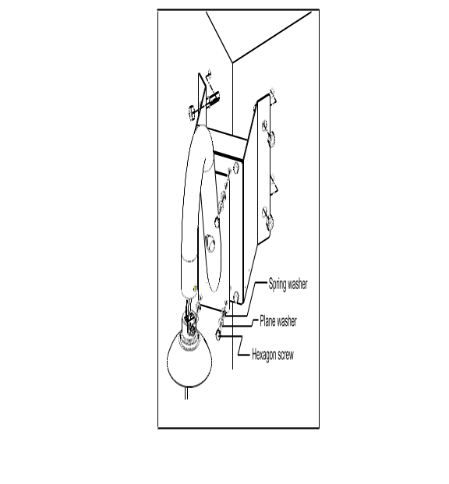

A-9: Pole Mount

A-9-1 Pole Thin/Wide Direct Mounting
The dome can be installed on a pole with a thin or wide pole mounting accessory and a gooseneck.

1) Fasten the suspension mounting plate on a pole with equipped stainless straps
2) Fix the gooseneck tube on the pole mounting plate
3) Thread the cables through the gooseneck tube and the Indoor Mount kit and connect them to the speed dome camera
4) Fix the Indoor Mount kit to the gooseneck tube using the screws and washers.

Pole Direct Mounting: Pole Thin/Wide Direct Mounting +Gooseneck Tube + Indoor Mount Kit

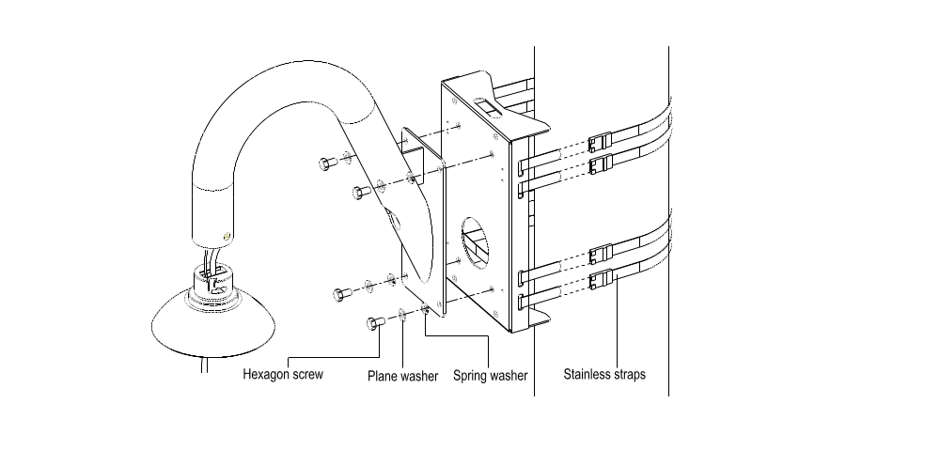

A-9-2 Pole Thin/Wide Box Mounting
Follow the steps to mount the PTZ camera with the pole box and gooseneck tube.

1) Fasten the pole box on a pole with equipped stainless straps
2) Fix the gooseneck tube to the pole box
3) Thread the cables through the gooseneck tube and the top holder and connect them to the PTZ camera
4) Fix the top holder to the gooseneck tube using the screws and washers.
5) Attache the PTZ camera to the top holder and fix them with the screw.

Pole Box Mounting: Pole Thin/Wide Box + Gooseneck Tube + Indoor Mount Kit

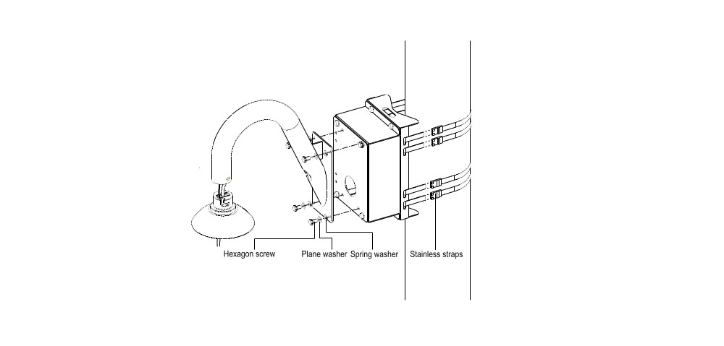

Appendix B: OSD Menu Notes

B-1: OSD Display Format
The information shown on the screen are described in terms of OSD display, position and function description in the table below.

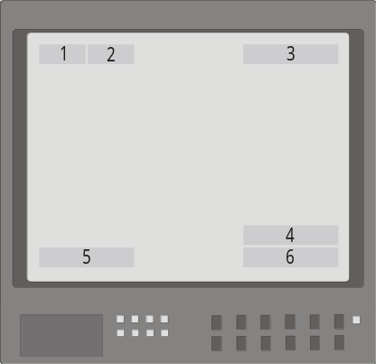

Position | Function | OSD Display | Description
1 | Focus Modes | A | Auto Focus Mode
1 | Focus Modes | M | Manual Focus Mode
2 | Backlight | X | Back Light Compensation OFF
2 | Backlight | B | Back Light Compensation ON
3 | Alarm | ALARM | Alarm Message
4 | Zoom Ratio | ×1 | Present Zoom Ratio  (Optical Zoom(Digital Zoom)
5 | Title | - Maximum 20 characters for each title.  - 16 sets of title are available.
6 | Camera ID | Show the camera ID

B-2: OSD Setup Menu
The OSD setup menu structure of 18x model and 22x model/23x model are listed separately in the following section. The star symbol indicates the factory default.

For detailed function description, please see section B-3 Configuration Menu

- 18x MODEL
Item | Layer 1 | Layer 2 |  |  | Layer 3 | Default
DEFAULT CAMERA | <ON>, <OFF> |  |  |  |  | ON
BACKLIGHT | <ON>, <OFF> |  |  |  |  | OFF
FOCUS | AUTO | AF Mode <Normal>, <Interval>, <Zoom Trigger> |  |  |  | Normal
FOCUS | MANUAL | Focus Manual Speed <01>~<08>
AE MODE | AUTO | Exposure Comp. <OFF>, <1>~<15> |  |  |  | OFF
AE MODE | BRIGHT | Bright <0> ~ <31>
AE MODE | SHUTTER | Shutter Speed <1> ~ <1/10000> Sec.
AE MODE | GAIN | Gain <-3> ~ <28>dB
AE MODE | IRIS | Iris <Close>, <F1.6> ~ <F28>
WBC MODE | AUTO (Auto White Balance) |  |  |  |  | ☆
WBC MODE | INDOOR
WBC MODE | OUTDOOR
WBC MODE | ATW (Auto-tracing WBC)
WBC MODE | MANUAL | R Gain <000> ~ <128>
WBC MODE | MANUAL | B Gain <000> ~ <128>
ID DISPLAY | <ON>, <OFF> |  |  |  |  | ON
SETUP MENU 1 | FLIP | <IMAGE>, <M.E.>, <OFF> |  |  |  | OFF
SETUP MENU 1 | ZOOM SPEED | <1> ~ <8> |  |  |  | 8
SETUP MENU 1 | SPEED BY ZOOM | <ON>, <OFF> |  |  |  | OFF
SETUP MENU 1 | AUTO CALI. | <ON>, <OFF> |  |  |  | OFF
SETUP MENU 1 | DIGITAL ZOOM | <ON>, <OFF> |  |  |  | ON
SETUP MENU 1 | SLOW SHUTTER | <ON>, <OFF> |  |  |  | OFF
SETUP MENU 1 | ANGLE ADJUSTER | ADJUST MIN ANGLE |  |  |  | 00
SETUP MENU 1 | ANGLE ADJUSTER | ADJUST MAX ANGLE |  |  |  | 90
SETUP MENU 1 | ANGLE ADJUSTER | RESET
SETUP MENU 1 | RESET | <YES>
SETUP MENU 1 | EXIT
SETUP MENU 2 | APERTURE | <01> ~ <16> |  |  |  | 01
SETUP MENU 2 | MASK DISPLAY | <FIRST>, <LAST> |  |  |  | First
TITLE DISPLAY | <ON>, <OFF> |  |  |  |  | OFF
TITLE SETTING | <01> ~ <16> |  |  |  |  | 01
ALARM SETTNG | ALARM PIN | <1> ~ <8> |  |  |  | 1
ALARM SETTNG | ALARM SWITCH | <ON>, <OFF> |  |  |  | OFF
ALARM SETTNG | ALARM TYPE | <N.O.> (Normal Open), <N.C.> (Normal Close) |  |  |  | N.C.
ALARM SETTNG | ALARM ACTION | PRESET |  |  |  | ☆
ALARM SETTNG | ALARM ACTION | SEQUENCE
ALARM SETTNG | ALARM ACTION | AUTOPAN
ALARM SETTNG | ALARM ACTION | CRUISE
ALARM SETTNG | PRESET POINT  SEQUENCE LINE  AUTOPAN LINE  CRUISE LINE | <001> ~ <256>  <1> ~ <8>  <1> ~ <4>  <1> |  |  |  | 001
ALARM SETTNG | DWELL TIME | <001> ~ <127> Sec., <ALWAYS> |  |  |  | ALWAYS
ALARM SETTNG | EXIT | YES
HOME SETTING | HOME FUNC. | <ON>, <OFF> |  |  |  | OFF
HOME SETTING | SELECT MODE | PRESET |  |  |  | ☆
HOME SETTING | SELECT MODE | SEQUENCE
HOME SETTING | SELECT MODE | AUTOPAN
HOME SETTING | SELECT MODE | CRUISE
HOME SETTING | PRESET POINT  SEQUENCE LINE  AUTOPAN LINE  CRUISE LINE | <001> ~ <256>  <1> ~ <8>  <1> ~ <4>  <1> |  |  |  | 001
HOME SETTING | RETURN TIME | <001> ~ <128> Min. |  |  |  | 001
HOME SETTING | GO | ENTER
HOME SETTING | EXIT
SEQUENCE | SEQUENCE LINE | <1> ~ <8> |  |  |  | 1
SEQUENCE | SEQUENCE POINT | <01> ~ <32> |  |  |  | 01
SEQUENCE | PRESET POS. | <001> ~ <256> |  |  |  | 001
SEQUENCE | SPEED | <01> ~ <15> |  |  |  | 01
SEQUENCE | DWELL TIME | <000> ~ <127> Sec. |  |  |  | 000
SEQUENCE | RUN SEQUNECE
SEQUENCE | EXIT
AUTOPAN | AUTOPAN LINE | <1> ~ <4> |  |  |  | 1
AUTOPAN | START POINT | <TO FIND>, <TO SAVE>
AUTOPAN | END POINT | <TO FIND>, <TO SAVE>
AUTOPAN | DIRECTION | <RIGHT>, <LEFT> |  |  |  | Right
AUTOPAN | SPEED | <01> ~ <04> |  |  |  | 01
AUTOPAN | RUN AUTOPAN
AUTOPAN | EXIT
CRUISE | RECORD START
CRUISE | RECORD END
CRUISE | RUN CRUISE
CRUISE | EXIT
IR FUNCTION  (F/U model only) | <AUTO>, <ON> |  |  |  |  | Auto
ALARM DETECT | DETECT SWITCH | <ON>, <OFF> |  |  |  | OFF
ALARM DETECT | DETECT MODE | <INT. FOCUS>, <FIX FOCUS>, <INT. AE>, <FIX AE> |  |  |  | Int. Focus
ALARM DETECT | EXIT
PRIVACY | PRIVACY SWITCH | <ON>, <OFF> |  |  |  | OFF
PRIVACY | TRANSPARENCY | <ON>, <OFF> |  |  |  | OFF
PRIVACY | COLOR | <BLACK>, <HEAVY GRAY>, <LIGHT GRAY>, <WHITE>, <RED>, <GREEN>, <BLUE>, <CYAN>, <YELLOW>, <MAGENTA> |  |  |  | Black
PRIVACY | SET MASK | <01> ~ <24> |  | H CENTER <L>, <R>
PRIVACY | SET MASK |  |  | V CENTER <D>, <U>
PRIVACY | SET MASK |  |  | H SIZE <00> ~ <80>
PRIVACY | SET MASK |  |  | V SIZE <00> ~ <60>
PRIVACY | EXIT | YES
TIME | TIME DISPLAY | <ON>, <OFF> |  |  |  | OFF
TIME | SET YEAR
TIME | SET MONTH
TIME | SET DAY
TIME | SET HOUR
TIME | SET MINUTE
TIME | EXIT+SAVE
EXIT OSD | YES

- 22x MODEL / 23x MODEL
Item | Layer 1 | Layer 2 |  |  | Layer 3 | Default
DEFAULT CAMERA | <ON>, <OFF> |  |  |  |  | ON
BACKLIGHT | ON | BLC Level <000> ~ <100>
BACKLIGHT | OFF |  |  |  |  | ☆
FOCUS | AUTO | Focus Length <1cm>, <10cm>, <30cm> <1m> |  |  |  | 10 cm
FOCUS | MANUAL | <01> ~ <08>
APERTURE | AUTO |  |  |  |  | ☆
APERTURE | MANUAL | H APERTURE <00> ~ <31>
APERTURE | MANUAL | V APERTURE <00> ~ <31>
AE MODE | AUTO | IRIS OFFSET <00> ~ <99> |  |  |  | 50
AE MODE | SHUTTER | SHUTTER SPEED <1/2> ~ <1/30000>
AE MODE | IRIS | IRIS <00> ~ <09>
AE MODE | AGC | AGC <00> ~ <05>
WBC MODE | AUTO |  |  |  |  | ☆
WBC MODE | MANUAL | R Gain <00> ~ <99>
WBC MODE | MANUAL | B Gain <00> ~ <99>
ID DISPLAY | <ON>, <OFF> |  |  |  |  | ON
SETUP MENU | FLIP | <IMAGE>(K model only), <M.E.>, <OFF> |  |  |  | OFF
SETUP MENU | ZOOM SPEED | <FAST>, <SLOW> |  |  |  | Slow
SETUP MENU | SPEED BY ZOOM | <ON>, <OFF> |  |  |  | OFF
SETUP MENU | AUTO CALI. | <ON>, <OFF> |  |  |  | OFF
SETUP MENU | DIGITAL ZOOM | <1> ~ <12>, <OFF> |  |  |  | OFF
SETUP MENU | SLOW SHUTTER  (K model only) | <1/2> ~ <1/60> Sec. (NTSC)  <1/1.5> ~ <1/50> Sec. (PAL) |  |  |  | 1/30
SETUP MENU | ANGLE ADJUSTER | ADJUST MIN ANGLE |  |  |  | 00
SETUP MENU | ANGLE ADJUSTER | ADJUST MAX ANGLE |  |  |  | 90
SETUP MENU | ANGLE ADJUSTER | RESET
SETUP MENU | RESET | YES
SETUP MENU | EXIT
TITLE DISPLAY | <ON>, <OFF> |  |  |  |  | OFF
TITLE SETTING | <01> ~ <16> |  |  |  |  | 01
ALARM SETTNG | ALARM PIN | <1> ~ <8> |  |  |  | 1
ALARM SETTNG | ALARM SWITCH | <ON>, <OFF> |  |  |  | OFF
ALARM SETTNG | ALARM TYPE | <N.O.>, <N.C.> |  |  |  | N.C.
ALARM SETTNG | ALARM ACTION | PRESET |  |  |  | ☆
ALARM SETTNG | ALARM ACTION | SEQUENCE
ALARM SETTNG | ALARM ACTION | AUTOPAN
ALARM SETTNG | ALARM ACTION | CRUISE
ALARM SETTNG | PRESET POINT  SEQUENCE LINE  AUTOPAN LINE  CRUISE LINE | <001> ~ <256>  <1> ~ <8>  <1> ~ <4>  <1> |  |  |  | 001
ALARM SETTNG | DWELL TIME | <001> ~ <127> Sec., ALWAYS |  |  |  | ALWAYS
ALARM SETTNG | EXIT | YES
HOME SETTING | HOME FUNC. | <ON>, <OFF> |  |  |  | OFF
HOME SETTING | SELECT MODE | PRESET |  |  |  | ☆
HOME SETTING | SELECT MODE | SEQUENCE
HOME SETTING | SELECT MODE | AUTOPAN
HOME SETTING | SELECT MODE | CRUISE
HOME SETTING | PRESET POINT  SEQUENCE LINE  AUTOPAN LINE  CRUISE LINE | <001> ~ <256>  <1> ~ <8>  <1> ~ <4>  <1> |  |  |  | 001
HOME SETTING | RETURN TIME | <001> ~ <128> Min. |  |  |  | 001
HOME SETTING | GO | ENTER
HOME SETTING | EXIT | YES
SEQUENCE | SEQUENCE LINE | <1> ~ <8> |  |  |  | 1
SEQUENCE | SEQUENCE POINT | <01> ~ <32> |  |  |  | 01
SEQUENCE | PRESET POS. | <001> ~ <255>, <END> |  |  |  | 001
SEQUENCE | SPEED | <01> ~ <15> |  |  |  | 01
SEQUENCE | DWELL TIME | <000> ~ <127> Sec. |  |  |  | 000
SEQUENCE | RUN SEQUNECE | ENTER
SEQUENCE | EXIT
AUTOPAN | AUTOPAN LINE | <1> ~ <4> |  |  |  | 1
AUTOPAN | START POINT | <TO FIND>, <TO SAVE>
AUTOPAN | END POINT | <TO FIND>, <TO SAVE>
AUTOPAN | DIRECTION | <RIGHT>, <LEFT> |  |  |  | Right
AUTOPAN | SPEED | <01> ~ <04> |  |  |  | 01
AUTOPAN | RUN AUTOPAN | ENTER
AUTOPAN | EXIT
CRUISE | RECORD START
CRUISE | RECORD END
CRUISE | RUN CRUISE
CRUISE | EXIT
IR FUNCTION  (K model only) | AUTO | THRESHOLD |  | <LOW>, <MID>, <HI> |  | LOW
IR FUNCTION  (K model only) | AUTO | IR COLOR |  | <B/W>, <COLOR> |  | B/W
IR FUNCTION  (K model only) | AUTO | EXIT
IR FUNCTION  (K model only) | ON
WDR SETTING  (K model only) | WDR SWITCH | <ON>, <OFF> |  |  |  | OFF
WDR SETTING  (K model only) | WDR FUNCTION | AUTO |  |  |  | ☆
WDR SETTING  (K model only) | WDR FUNCTION | MANUAL | RATIO LEVEL <000>~<128>
WDR SETTING  (K model only) | WDR FUNCTION | MANUAL | SHUTTER LEVEL <000>~<128>
WDR SETTING  (K model only) | WDR FUNCTION | MANUAL | IRIS OFFSET <000>~<128>
WDR SETTING  (K model only) | EXIT
PRIVACY  (K model only) | PRIVACY SWITCH | <ON>, <OFF> |  |  |  | OFF
PRIVACY  (K model only) | SHADE | <BLACK>, <WHITE>, <GRAY> |  |  |  | Gray
PRIVACY  (K model only) | SET MASK | <1> ~ <8> | H CENTER <000> ~ <256>
PRIVACY  (K model only) | SET MASK | <1> ~ <8> | V CENTER <000> ~ <256>
PRIVACY  (K model only) | SET MASK | <1> ~ <8> | H SIZE <000> ~ <127>
PRIVACY  (K model only) | SET MASK | <1> ~ <8> | V SIZE <000> ~ <127>
PRIVACY  (K model only) | MASK CLEAR+RESET | <01> ~< 08> |  |  |  | 01
PRIVACY  (K model only) | MASK DSIPLAY | <FIRST>, <LAST> |  |  |  | First
PRIVACY  (K model only) | EXIT | YES
TIME | TIME DISPLAY | <ON>, <OFF> |  |  |  | OFF
TIME | SET YEAR
TIME | SET MONTH
TIME | SET DAY
TIME | SET HOUR
TIME | SET MINUTE
TIME | EXIT+SAVE
EXIT OSD | YES

B-3: Configuration Menu
The detailed functions and parameter settings of your high speed dome can be set by the OSD (On Screen Display) menu with a control program. The functions in OSD menu are described in the following sections.

18x MODEL 22x MODEL/23x MODEL
MAIN PAGE 1
DEFAULT CAMERAOFF
BACKLIGHTOFF
FOCUSAUTO
AE MODEAUTO
WBC MODEAUTO
ID DISPLAYON
SETUP MENU1
SETUP MENU2
MAIN PAGE 1
DEFAULT CAMERAOFF
BACKLIGHTOFF
FOCUSAUTO
APERTUREAUTO
AE MODE AUTO
WBC MODEAUTO
ID DISPLAYON
SETUP MENUENTER

B-3-1 DEFAULT CAMERA
The “DEFAULT CAMERA” is used to restore the camera settings (e.g. Backlight/Focus/AE//WBC/Aperture). Once any one of the items is modified, the setting will become <OFF> automatically. Select <ON> for this item to recall the mentioned camera parameters.

NOTE: On 18x MODEL, the Aperture function is provided in “SETUP MENU2”, instead of “DEFAULT CAMERA”.

B-3-2 BACKLIGHT
The Backlight compensation function prevents the center object from being too dark in surroundings where excessive light is behind the center object.

- 18x MODEL
Turn this item <ON>; the center object will be brightened in contrast to the edge of the picture (where a backlight would most likely be located).

- 22x MODEL / 23x MODEL
The Backlight Compensation Level ranges from 000 to 100.
BLC LEVEL
LEVEL20
EXITYES

NOTE: If this function is enabled, the WDR function (for 23x MODEL only) will be disabled automatically. For details, refer to section B-1-19 WDR Setting.

B-3-3 FOCUS
Automatically adjusts the focus position to maximize the high frequency content of the picture in a center measurement area, taking into consideration the high luminance and strong contrast components. The focus of the dome camera can be operated in two modes: Manual Focus mode and Auto Focus mode. Different settings for various models are described as follows.

- 18x MODEL
- AUTO
The optimum focus is achieved by the internal digital circuit. There are 3 modes for users to select for different conditions.

Normal AF (Auto Focus) Mode: The dome will automatically adjust the focus of the picture.
Zoom Trigger Mode: When the zoom ratio is changed, the dome will automatically adjust focus again after a period of time (the preset value is initially set for five seconds).
Interval AF Mode: The mode is used for AF movements carried out at particular intervals. If users pan/tilt the dome, the dome will focus automatically after a period of time. The initial value is five seconds.

- MANUAL
In this focus mode, users can adjust the lens focus manually.

- 22x MODEL / 23x MODEL
- AUTO
The optimum focus is achieved by the internal digital circuit. Users can adjust the minimum auto focus range for some special conditions; the options are <1cm>, <10cm>, <30cm> and <1m>.

- MANUAL
In this focus mode, users can adjust the lens focus manually.

FOCUS LENGTH
TURNING VALUE10CM
EXITYES

B-3-4 APERTURE
Sharpness is the subjective evaluation of detail in the picture. With this “APEATURE” function, users can adjust the enhancement of the edges of objects in the picture. When shooting text, this function may help by making them sharper and achieve a better image. There are 32 levels of adjustment, the options are <00> ~ <31>, <00> represents “no enhancement”.

- AUTO
The dome camera will assign a proper aperture value automatically for camera to achieve a better image.

- MANUAL
Select this item if you want to adjust aperture value manually. Higher value enhances the incident ray of camera.

APERTURE MENU
H APERTURE15
V APERTURE15

NOTE: For 18x MODEL, please refer to section B-1-9 SETUP MENU2 for information on Aperture function.

B-3-5 AE MODE
The exposure is the amount of light received by the image sensor and is determined by how wide you open the lens diaphragm (iris adjustment), by how long you keep the sensor exposed (shutter speed), and other exposure parameters. With this item, users can define how the Auto Exposure (AE) function works.

- 18x MODEL
- AUTO
In this mode, the camera’s IRIS and AGC (Auto Gain Control) control circuits work together automatically to adjust the light exposure of image sensor in order to get consistent video output level. At this condition the shutter speed is fixed at 1/60 (NTSC) or 1/50(PAL). Users can offset the internal brightness reference level through auto Exposure Comp. to control the brightness of camera. The value of Exposure Comp. is selectable from <0> to <16> and the gain varies from -10.5 dB to 10.5 dB. Each step is 1.5 dB; the Exposure Comp. vaue <7> is equal to gain value 0 dB. The camera will not compensate brightness when the Exposure Comp. is set to <OFF>. The default setting is <OFF>.

- BRIGHT
The brightness control function adjusts IRIS and AGC gain using an internal algorithm. The brightness is controlled by gain when the light condition is dark and by iris when the light condition is bright.

- SHUTTER
With this option, the SHUTTER speed takes main control of the exposure, and both IRIS and AGC will function automatically in cooperation with shutter speed to achieve consistent exposure output.

- GAIN
The auto GAIN control function takes main control of exposure with priority over SHUTTER and IRIS. The internal circuit will function automatically to get consistent exposure.

- IRIS
With this option, the IRIS function adjust the exposure in higher property. SHUTTER speed and AGC circuit will function automatically in cooperating with IRIS to get consistent exposure output. The opening of a lens controls the amount of light reaching the surface of the selected device. By increasing the F-stop number (F/1.6, F/2, F/2.4, etc.), less light is permitted to pass.
- 22x MODEL / 23x MODEL
- AUTO
In this mode, the camera’s Shutter, IRIS and AGC control function work automatically to compensate the light exposure of image sensor for consistent video output level. IRIS OFF SET is used to set the level of IRIS variation.

- SHUTTER
With this option, the SHUTTER priority is higher than IRIS and AGC; IRIS and AGC circuit will function automatically in cooperating with SHUTTER to get consistent exposure.

- IRIS
With this option, the IRIS priority is higher than SHUTTER and AGC; SHUTTER and AGC circuit will function automatically in cooperating with IRIS to get consistent exposure. If the IRIS is modified manually, the action of exposure compensation depends on the AGC circuit.

- AGC
With this option, the AGC priority is higher than SHUTTER and IRIS; SHUTTER and IRIS circuit will function automatically in cooperating with AGC to get consistent exposure. If AGC is adjusted manuall, the exposure compensation depends on the changing of IRIS.

B-3-6 WBC MODE
A digital camera needs to find reference colour temperature, which is a way of measuring the quality of a light source, for calculating all the other colours. The unit for measuring this ratio is in degree Kelvin (K). You can select one of the White Balance Control modes according to the condition. The following table shows the colour temperature of some light sources.
Light Sources | Color Temperature in K
Cloudy Sky | 6,000 to 8,000
Noon Sun and Clear Sky | 6,500
Household Lighting | 2,500 to 3,000
75-watt Bulb | 2,820
Candle Flame | 1,200 to 1,500
- 18x MODEL
- AUTO
In this mode, white balance works within its colour temperature range. This mode computes the white balance value output using colour information from the entire screen. It outputs the proper value using the colour temperature radiating from a black subject based on a range of values from 3000K to 7500K.

- INDOOR
3200K Base mode

- OUTDOOR
5800K Base mode

- ATW
Auto Tracing White Balance mode. The dome taking out the signals in a screen in the range from 2000K to 10000K.

- MANUAL
In this mode, users can change the White Balance value manually; R gain and B gain are adjustable and range from 0 to 128.

WBC MENU
R GAIN50
B GAIN50

- 22x MODEL / 23x MODEL
- AUTO
In this mode, white balance works within its colour temperature range and calculates the best-fit white balance.

- MANUAL
In this mode, users can change the White Balance value manually; adjustable R gain and B gain range from 0 to 99.

WBC MENU
R GAIN50
B GAIN50

B-3-7 ID DISPLAY
Users are allowed to choose whether the dome ID will be displayed on monitor to identify the domes.

- ON
Display the ID address of the selected dome on the right bottom of the monitor screen.

- OFF
Hide the ID address of the selected dome.

B-3-8 SETUP MENU
Users can adjust camera lens model parameters under SETUP MENUs. Depending on the model of dome cameras, the SETUP MENUs are different.

18x MODEL

SETUP MENU1
FLIPENTER
ZOOM SPEED1
SPEED BY ZOOMOFF
AUTO CALI.OFF
DIGITAL ZOOM12
SLOW SHUTTEROFF
ANGLE ADJUSTERENTER
RESETYES
EXITYES
SETUP MENU2
APERTURE01
MASK DISPLAYFIRST

22x MODEL / 23x MODEL

SETUP PAGE
FLIPON
ZOOM SPEEDFAST
SPEED BY ZOOMON
AUTO CALI.OFF
DIGITAL ZOOM12
SLOW SHUTTER1/2
ANGLE ADJUSTERENTER
RESETYES
EXITYES

- FLIP (IMAGE/ME/OFF)
User can track an object continuously when it passes through under dome camera with setting Flip to IMAGE (digital flip) or M.E. (mechanical flip).

FLIP SETTING
FLIPOFF
EXITYES

IMAGE
IMAGE represents digital IMAGE FLIP, enables users to keep tracking object seamlessly and no delay occurs in comparing with mechanical flip.

NOTE: The Privacy Mask function will be automatically disabled if the Image Flip function is enabled, and “Masking will be disabled” will be displayed on the screen.
M.E.
The item is a standard mechanical operation. As the dome tilts 90°, it will pan 180°, then continuing tilt to keep tracking object.

OFF
Select this item to disable the flip function.

NOTE: The speed dome will only be able to tilt 90°, or -10° ~ 100° with angle adjuster adjustments.
- ZOOM SPEED
This item is used to set the zoom speed for operating the dome camera.
- 18x MODEL
For this model, the zoom speed options are <1> (slow) ~ <8> (fast). The default is <8>

- 22x MODEL / 23x MODEL
For these two models, the options are <FAST> and <SLOW> (default).

- SPEED BY ZOOM
If the item is set to <ON>, the pan/tilt speed will be adjusted by internal algorithm when zooming automatically. The larger zoom ratio leads the lower rotation speed.

- AUTO CALIBRATION
There are one horizontal and one vertical infrared rays check points in each dome. When the dome camera position may be moved during installation or maintenance, the relative distance between the original set point and the check point has been changed. Enable the Auto Calibration function, the dome will automatically detect that and reset the point baack to the original position.

- DIGITAL ZOOM
With this item, users can enable or disable the 12x Digital Zoom. The Digital Zoom activate after the full Optical Zoom level is reached.

NOTE: The difference between optical and digital zoom is that optical zoom uses the lens within the camera to draw the image closer via zoom in or out to achieve the desired effect. Optical zoom remains the same and the full resolution of the zoomed image quality. On the other hand, Digital zoom takes a portion of image and expands that image to the full size of the image; however the image quality will be reduced.
- 18x MODEL
For this model, maximum 12x digital zoom function is allowed to be enabled. The default setting is <ON>

- 22x MODEL / 23x MODEL
For these two models, Digital zoom ration is adjustable from <1> to <12>.
- SLOW SHUTTER
The shutter speed determines how long the image sensor is exposed to light. To see clear image in a dark environment, enable this function and select a slower shutter speed.

- 18x MODEL
As enable this digital slow shutter function, the dome will automatically adjust the shutter speed basing on the light condition of installation environment. It enables users to see objects in a dark environment under 0.2 lux.

- 23x MODEL
The shutter speed is adjustable on 23x MODEL. With the slowest shutter speed, users can see objects in a dark environment under 0.2 lux; or see a smooth video image with a higher shutter speed. The options are from <1/2> to <1/60>.

- ANGLE ADJUSTER
The item is for adjusting the camera view angle. The ranges of view angle are changed in different FLIP mode: the angle ranges from -10° to +100° with ME FLIP and FLIP OFF modes, and from -10° ~ +190° with IMAGE FLIP mode. With IMAGE FLIP function, users are able to adjust the view angle from -10° ~ +190° to catch the true horizontal line.

ANGLE ADJUSTER
ADJUST MIN ANGLE -10 DEG
ADJUST MAX ANGLE 100 DEG
EXIT+SETYES

- RESET
Select this item to reset all the camera parameters of SETUP MENUs to the factory dfault.

- EXIT
Exit the SETUP MENU1 and go back to MAN MENU.

B-3-9 SETUP MENU2 (18x MODEL Only)
The Aperture and Mask Display settings can be configured under SETUP MENU2.

SETUP MENU2
APERTURE01
MASK DISPLAYFIRST

- APERTURE
Under this setup menu, users can adjust the enhancement of the edges of objects in the picture. There are 16 levels of adjustment; the options are <01) ~ <16>, <01> represents “no enhancement”. When shooting text, this function may help by making them sharper.

- MASK DISPLAY
In this item, users can set the occasion to display the Privacy Mask, which aims to avoid any intrusive monitoring. If preset point function or sequence function is activated, the difference of the two display mode will be obvious.

FIRST
If select this display mode and activate preset or sequence functions, the camera will detect and display the masks set in the next area first, then rotates the dome to the next preset point.
LAST
If select this display mode and activate preset or sequence functions, the dome will move the next preset point zone, then detect and display mask set in that zone.

NOTE: Setting privacy mask with 1x optical zoom, and setting the sequence speed value higher than 10 is recommended.

B-3-10 TITLE DISPLAY
User are allowed to name a certain view area and display its title for easy recognition. At this item, users can choose to display or not to display the titles set in advance.
- ON
A title set for certain view will be displayed when the dome back to the view area.

- OFF
When the TITLE DISPLAY is set <OFF>, no title will be displayed on the screen even titles are set in advance.

B-3-11 TITLE SETTING
Up to 16 zone titles can be set with maximum 20 characters for each title; two mask zones are allowed to set in a view area. Users can name the zone titles with privacy mask ID numbers for future recognition.

NOTE: For 23x MODEL, the available area for setting privacy mask is restricted within tilt angle 45°.
Follow the steps to set a camera title.
        - Operate speed dome to certain view area where you want to set a title for it.
        - Turn on OSD and select <TITLE SETTING>.
        - Select a number to indicate the view area.
        - Press <ENTER> to go into editing mode.
TITLE SETTING: 01
 | 0 | 1 | 2 | 3 | 4 | 5 | 6 | 7 | 8 | 9 | EXIT
 | A | B | C | D | E | F | G | H | I | J | SAVE
 | K | L | M | N | O | P | Q | R | S | T | LEFT
 | U | V | W | X | Y | Z | : | / | . | , | RIGHT
 | [ | ] | + | ? | - |  |  |  |  |  | DELETE
TITLE:
ABC

        - Choose a character with direction keys and then press <ENTER> to input.
Example: <A> <ENTER>, <B> <ENTER>, <C> <ENTER>
TITLE: ABC
        - To delete entered characters, move the cursor to <LEFT> or <RIGHT> and press <ENTER> to select a character in entry field, then move the cursor to <DELETE> and press <ENTER> to delete the selected character.
        - When the setting is completed, move the cursor to <SAVE> and press <ENTER> to save.

B-3-12 ALARM SETTING
The integrated high speed dome provides eight alarm inputs and two alarm outputs (N.O. and N.C.) to connect alarm devices. With this function, dome will cooperates with alarm system to catch the event images. For wiring, please refer to the installation guide and/or qualified service personnel. Alarm parameters can be set on this page.

ALARM SETTING
ALARM PIN1
ALARM SWITCHOFF
ALARM TYPEN.C.
ALARM ACTIONPRESET
PRESET POINT001
DWELL TIMEALWAY
EXITYES

- ALARM PIN
The dome provides 8 alarm inputs and 2 outputs ( 1 x N.O. and 1 x N.C.). Select an alarm connector which you want to set its alarm-related parameters with this item, and then set its alarm-related parameters in Alarm Setting menu.

- ALARM SWITCH
The item is used to enable or disable the selected alarm pin function.

- ALARM TYPE
There are two kinds of alarm types: Normal Open and Normal Close, which are illustrated as below. Select an alarm type that corresponds with the alarm application.

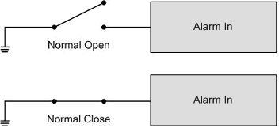

- ALARM ACTION
Select one of these modes that choose a kind of actions that should be executed when an alarm is triggered. The alarm actions can be set to execute the preset position, sequence, auto-pan or cruise function.

- PRESET
Select a preset point where the dome should go when an alarm pin is triggered.
SEQUENCE
Select a sequence line that the speed dome camer should execute when alarm pin is triggered. The Sequence line should be defined prior in SEQENCE setup menu.
AUTOPAN
Select an auto-pan line that the dome camera should execute when alarm pin is triggered. The Auto-pan line can be defined in setup AUTOPAN menu.
CRUISE
Select a cruise line that the speed dome camera should execute when alarm pin is triggered. The Cruise line can be defined in CRUISE setup menu.

- DWELL TIME
The DWELL TIME is the duration of executing ALARM ACTION: Preset or Sequence. When alarm takes place, the dome will go to the preset position or execute sequence function and stay at each sequence point for a period of time (1~127 seconds). If select <Always>, the dome will go to the preset position and stay there until alarm condition is released or users rotate the dome.

NOTE: The DWELL TIME is only accessible when selecting ALARM ACTION: Preset or Sequence.
- EXIT
Exit the ALARM SETTING menu.

B-3-13 HOME SETTING
Users are able to set an operation mode to ensure constant monitoring; if the dome idles for a period of time, the pre-set function will be activated automatically, this is the HOME function. HOME function allows constant and accurate monitoring, to avoid the speed dome stops or missing events.

HOME SETTING
HOME FUNCTIONOFF
SELECT MODEPRESET
PRESET POINT001
RETURN TIME001
GOENTER
EXITYES

- HOME FUNCTION
The item is used to enable or disable the HOME function.

- SELECT MODE
Select one of the modes that the dome should execute when HOME function is enabled and the RETURN TIME is up. The options are <AUTOPAN>, <SEQUENCE>, <CRUISE> and <PRESET>.

- PRESET
Select a preset point where the speed dome should go when alarm pin is triggered.

SEQUENCE
Select a sequence line that the speed dome camer should execute when alarm pin is triggered. The Sequence line should be defined prior in SEQENCE setup menu.
AUTOPAN
Select an auto-pan line that the speed dome camera should execute when alarm pin is triggered. The Auto-pan line can be defined in setup AUTOPAN setup menu.
CRUISE
Select a cruise line that the speed dome camera should execute when alarm pin is triggered. The Cruise line can be defined in CRUISE setup menu.

- RETURN TIME
The speed dome starts to count down RETURN TIME when the dome idles, and will execute the SELECT MODE function if the return time is up. The RETURN TIME ranges from 1 to 128 minutes.
- GO
If HOME function is enabled, the users are allowed to execute HOME function manually by selecting this item.

- EXIT
Exit the HOME SETTING menu.

B-3-14 SEQENCE
The function executes pre-positioning of the pan, tilt, zoom and focus features in a certain sequence for a camera. Before set up this function, users must setup at least two preset points.

SEQUENCE
SEQUENCE LINE1
SEQUENCE POINT01
PRESET POSITION001
SPEED1
DWELL TIME001
RUN SEQUENCEENTER
EXITYES

- SEQUENCE LINE
There are eight sets of sequence lines built in the speed dome camera. Using LEFT/RIGHT direction keys to select a line first and then set its sequence points.

- SEQUENCE POINT
Up to 32 points can be specified for each sequence line. The sequence points represent the orders of the preset points that the dome will automatically run, and the bellowing setup items, PRESET POSITION, SPEED, and DWELL TIME, are related to this item.

- PRESET POSITION
Users can assign a specific preset position to the selected sequence point with this item.

- SPEED
Users can set the Speed that the dome goes to the next sequence point, and setup speed range is from 1 ~ 15. Refer to below table for more information.

 | PAN (degree/sec.) | TILT (degree/sec.)
Speed 1 | 10 | 8
Speed 2 | 23 | 12
Speed 3 | 35 | 22
Speed 4 | 45 | 30
Speed 5 | 55 | 40
Speed 6 | 65 | 50
Speed 7 | 75 | 58
Speed 8 | 185 | 185
Speed 9 | 205 | 210
Speed 10 | 225 | 240
Speed 11 | 250 | 275
Speed 12 | 280 | 305
Speed 13 | 320 | 335
Speed 14 | 365 | 365
Speed 15 | 400 | 400

- DWELL TIME
The DWELL TIME is the duration time that the speed dome will stay at the sequence point, and the range is from <0> to <127> seconds. The speed dome will go to the next sequence point when the DWELL TIME is up. If the setting is <0>, the speed dome will stay at this sequence point until users manually move the speed dome.

- RUN SEQUENCE
User can command the speed dome camera to run the selected Sequence line manually.

- EXIT
Select the item to exit the SEQUENCE menu.

B-3-15 AUTOPAN
Auto-pan means rotating or scanning side-to-side motion by a speed dome camera to view an area horizontally. The parameters can be set on this page.

AUTOPAN
AUTOPAN LINE1
START POINTTO FIND
END POINTTO FIND
DIRECTIONRIGHT
SPEED1
RUN AUTOPANENTER
EXITYES

- AUTOPAN LINE
There are four sets of auto-pan lines built in speed dome camera. Users are able to command the speed dome camera to do continuously panning without limit by setting the start point the same as endpoint.

- START POINT
Follow the description to set the start position of the AUTOPAN path.
- Move the cursor to <START POINT> and press <ENTER> while <TO FIND> item flashes, the item will turn <TO SAVE> automatically.
- Move the speed dome to a desired position and press <ENTER> to save the position as the start point; the cursor will move to <END POINT> automatically. Ensure to set the end point to complete the auto-pan setting.

NOTE: The tilt and zoom value of the start point will be recorded and fixed for the selected auto-pan line.
- END POINT
Users are able to set the end point after the start point is defined. Pan the dome to another position and press <ENTER> to save the position as the end point.

- DIRECTION
The item is for setting the AUTOPAN direction of speed dome camera. The speed will start to pan clockwise from the start point to the end point if your selection is <RIGHT>, and then return to the start point. The speed dome will start to pan anti-clockwise from the start point to the end point if your selection is <LEFT>. Refer to below diagram.

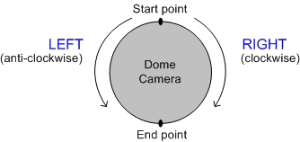

- SPEED
The item is for defining the speed dome camera rotation speed while running auto-pan. The speed is adjustable from 1 to 4; refer to the table below for details.

 | PAN (degree/sec.)
Speed 1 | 10
Speed 2 | 23
Speed 3 | 35
Speed 4 | 45

- RUN AUTOPAN
After the setting is completed, select this item to manually execute the Auto-pan function.

- EXIT
Exit the AUTOPAN setup menu.

B-3-16 CRUISE
A Cruise is a route of manual operations that can be stored and recalled to execute repeatedly. It can be formed of pan, tilt position and zoom parameters (the zoom setting only with 18x MODEL).

CRUISE
RECORD STARTENTER
RECORD ENDENTER
RUN CRUISEENTER
EXITYES

- RECORD START
Follow the description to record the CRUISE path.
- Rotate the speed dome camera to a desired view area. The percentage of the memory buffer will be displayed on the screen.
- Pan, tilt the dome camera to form a path. The zoom setting is only available with 18x MODEL.

NOTE: Beware of the memory size when building the cruise path. After the percentage of the buffer becomes 100%, the path will not be recorded.
- RECORD END
The cursor will be moved RECORD END while building the cruise line; when the setting is completed, press <ENTER> to save the path.

- RUN CRUISE
After the setting is completed, select this item to manually execute the Cruise function.

- EXIT
Exit the CRUISE setup menu.

B-3-17 IR FUNCTION (Removable IR Cut)
With the IR cut filter, the speed dome can still catch clear image at night time or very dark light condition. During day time, the IR cut filter will be on to block the infrared light for clear image; during night time, the IR cut filter will be removed to catch infrared light to view images in black and white. Only with 23x MODEL, users are able to view colur images when the IR function activated.

Refer to the description to operate the removable IR cut filter.

- 18x MODEL
- AUTO
The internal circuit will automatically decide the occasion to remove the IR cut filter according to the value of light condition calculated by the internal light algorithm.
- ON
Select the item to remove the IR cut filter.

- 23x MODEL

IR FUNCTION
THRESHOLDLOW
IR COLORCOLOR
EXITYES

- AUTO
The internal circuit will automatically decide the occasion to remove the IR cut filter according to the image brightness level.

THRESHOLD
The speed dome will remove the filter immediately when the threshold value is reached. The threshold options are <LOW>, <MID> and <HI>. <LOW> threshold indicates a higher sensitivity and can improve the reliability of lens.
IR COLOUR
When IR function is enabled, the video output can be programmed as colour or B/W.

- ON
Select the item to remove the IR cut filter.

B-3-18 ALARM DETECT (18x MODEL Only)
This function instructs the camera to detect movement within the monitoring area and then send an alarm signal automatically. To activate this function, alarm connection setups most be completed in advance.

ALARM DETECT
DETECT SWITCH OFF
DETECT MODE INT. FOCUS
EXIT YES

- DETECT SWITCH
The item is used to enable or disable the ALARM DETECTION function.
- DETECT MODE
Four alarm detect modes are provided for different application.

INT. FOCUS
The alarm will be triggered if the internal focus changes; and if the focus returns to the original position, the alarm will stop.
FIX FOCUS
If focus movement is detected, the alarm will be triggered, and the alarm stops when focus returns to the original position. Of the detected focus movement keeps changing for more than four seconds, the new focus position will be memorized as the reference and the alarm will stop.

NOTE: The INT. FOCUS and FIX FOCUS detect modes will be activated only with Auto Focus mode.
INT. AE
When Auto Exposure (AE) movement is detected, the alarm will be triggered; and if the Exposure Level returns to the original level, the alarm will stop.
FIX. AE
The alarm will be triggered if the Exposure value changes; if the adjusted AE value retains for four seconds, the value will be saved as the reference and the alarm will stops.

- EXIT
Exit this page.

B-3-19 WDR SETTING (23x MODEL Only)
The Wide Dynamic Range function is especially effective in solving indoor and outdoor contrast issues to enhance better image quality and video performance. It enables the speed dome to catch detailed data from the dark part (Indoor) without any saturation from the bright part (Outdoor). The parameter of WDR function can be set on this page.

WDR SETTING
WDR SWITCHOFF
WDR FUNCTIONAUTO
EXITYES
NOTE: The Backlight function will automatically turned off when the WDR function is enabled, because the WDR function has better effect than the Backlight compensation.

- WDR SWITCH
Enable or disable the WDR function with the item.

- WDR FUNCTION
The item is used to define the WDR function mode.

AUTO
If select <AUTO>, the speed dome camera operates the WDR function automatically.
MANUAL
Users are allowed to adjust WDR function manually by defining the RATIO LEVEL, SHUTTER SPEED and IRIS OFFSET value.

WDR MODE
RATIO LEVEL000
SHUTTER SPEED000
IRIS OFFSET000
EXITYES

- EXIT
Exit this setup menu.

B-3-20 PRIVACY
The Privacy Mask function aims to avoid any intrusive monitoring. Users can adjust the camera view position, and adjust the mask size and area. The speed dome camera will memorize the center of the selected view as an original point, so it will be locked as users enter the Privacy Setup menu. Refer to the description for setting Privacy masks.

NOTE: The Image Flip function will be disabled automatically while the Privacy function is enabled.

- 18x MODEL

PRIVACY MASK MENU
PRIVACY SWITCHON
TRANSPARENCYOFF
COLORBLACK
SET MASK01
EXITYES

- PRIVACY SWITCH
User can enable or disable the Privacy Mask function through this item.

- TRANSPARENCY
The colour of privacy mask can be set as transparent related to background image. Select <ON> to display transparent masks.

- COLOUR
The colour of privacy mask can be set through this item. The available colours are black, heavy gray, light gray, white, red, green, blue, cyan, yellow and magenta.

- SET MASK
Use the control device to move the speed dome camera to the area whether you want to set a mask. Press <ENTER> to enter MASK SETUP MENU. The speed dome will memorize this position as privacy mask position. Up to 24 masks can be set.

MASK01 MENU
H CENTERL/R
V CENTERU/D
H SIZE000
V SIZE000
EXIT+SAVEYES

H CENTER
The original horizontal center of mask zone is the center of screen; it is able to move to other position by adjusting the horizontal value.
V CENTER
The original vertical center of mask zone is the center of screen; it is able to move to other position by adjusting the vertical value.
H SIZE (00 ~ 80)
User can adjust the horizontal size of privacy mask through this item. Set the H and V size to 0 can also delete the selected mask.
V SIZE (00 ~ 60)
User can adjust the vertical size of privacy mask through this item. Set the H and V size to 0 can also delete the selected mask.

- EXIT
Exit this page.

- 23x MODEL

PRIVACY
PRIVACY SWITCHON
SHADEGRAY
SET MASK01
MASK CLEAR+RESET01
MASK DISPLAYFIRST
EXITYES

- PRIVACY SWITCH
The item is used to enable or disable masking function. Set this item to <ON> before configuring mask zone.

- SHADE
The colour of privacy mask can be selected through this item. The available colours are black, gray and white.

- SET MASK
Aftrer pressing <ENTER> on this item, speed dome will memorize this position as privacy mask position, up to 8 masks can be set. The model restricts the mask zones to be set too close with each other.

MASK01 MENU
H CENTER000
V CENTER000
H SIZE000
V SIZE000
EXIT+SAVEYES

H CENTER(000 ~ 256)
The original center of mask zone is the center of screen. User can move the center of mask zone to another position through adjust this value.
V CENTER(000 ~ 256)
The original center of mask zone is the center of screen. User can move the center of mask zone to another position through adjust this value.
H SIZE(000 ~ 127)
User can adjust the horizontal size of privacy mask through this item. Set the H and V size to 0 can also delete the selected mask.
V SIZE(000 ~ 127)
User can adjust the vertical size of privacy mask through this item. Set the H and V size to 0 can also delete the selected mask.

- MASK CLEAR+RESET
The item is used to clear the mask settings of the selected privacy mask. Select a mask and press <ENTER> to erase its configuration.

- MASK DISPLAY
This item is used to set the occasion to display privacy mask.

FIRST
If select this mode, the camera will detect the mask zone of the next preset position and display the mask in advance, then pan the speed dome to the preset point.
LAST
If select this mode, the camera will move the speed dome to the preset point, then display the mask zone.

NOTE: For 23x MODEL, the available area for setting privacy mask is restricted within tilt angle 45°, and two mask zones are allowed to set in a view area.
- EXIT
Exit this page.

B-3-21 TIME FUNCTION
The item is used to set the TIME related parameters of the integrated high speed dome.

TIME SETTING
TIME DISPLAYOFF
SET YEAR05
SET MONTH10
SET DAY02
SET HOUR12
SET MINUTE12
EXIT+SAVEYES

- TIME DISPLAY
Select <ON> to display the Time information on screen, or <NO> not to display.

- YEAR / MONTH / DAY
The items are for setting up the system date.

- HOUR / MINUTE
This items are for setting up the system time.

- EXIT+SAVE
Exit this page.

B-3-22 EXIT OSD
To exit the OSD setup menu, users can select this item.

