
IP Indoor High Speed Dome

CAM-6500 series

Ver. 081118

Quick Installation Guide

Getting Started


1.1 PACKAGE CONTENTS
CAM-6500 series Warranty Card
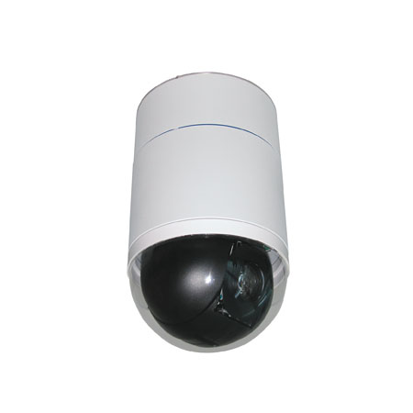

Software CD Power & A/V Cable
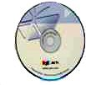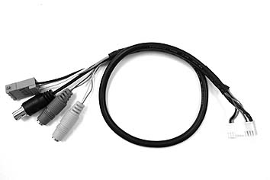

LAN/WAN Cable Power Adaptor (Option)
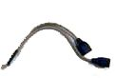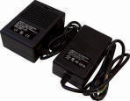

5.4” Transparent Cover Decoration Ring / Fixing Plate

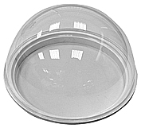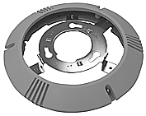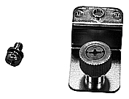

1.2 PHYSICAL DESCRIPTION
Indoor High Speed Dome Bottom

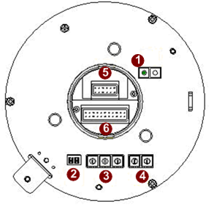

- Reset Button
Step 1: Switch off IP device by disconnecting the power cable
Step 2: Press and continue to hold the Reset Button. Reconnect the power cable while continuing to hold the reset button.
Step 3: Keep holding the reset button depressed around 6 seconds, release the reset button. The unit will start up with factory default settings.
- Communication Switch Setting
The table below shows the function of each pin within the Communication Switch.
Communication Switch | Pin 1 | RS-232 Setting (Reserved)
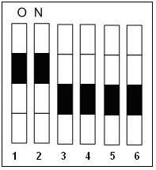 | Pin 2 | RS-232 Setting (Reserved)
 | Pin 3 | Termination
 | Pin 4 | Line Lock
 | Pin 5 | System Initialization (for upgrade)
 | Pin 6 | Reserved
RS-232 is reserved for internal use only; The Pin 3 and Pin 4, they are used for termination and Link Lock adjustment respectively. The Pin 5 is mainly used for return to factory default of camera setting.
- Dome ID Setting
Use the switch to change your speed dome ID by turning the arrow to the desired number respectively. For instance, if the speed dome ID is 123, the ID switch should be set as below:

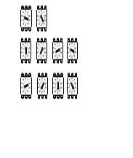
centesimal decimal single digit
 | NOTE: No two speed domes should be given the same ID, or communication conflict may occur.
 | NOTE: The number “0” should locate upwards as shown in above diagram for correct switch definition.
- Dome Control Protocol
Protocol is a specific set of rules, procdures used for data communications. Basing on the protocol of your management software that you are going to use. Use the switch to set your dome control protocol and the baud rate. Refer to table below and turn the arrow to choose a protocol for your speed dome.
Switch No. | Protocol | Baud Rate
01 | Pelco D | 2400
02 | Pelco P | 4800
07 | DSCP | 9600
11 | Pelco D | 4800
12 | Pelco D | 9600
13 | Pelco P | 2400
14 | Pelco P | 9600
Select protocol: Pelco D, with switch no. 01 and baud rate 2400, for instance, the ID switch should be set as below:
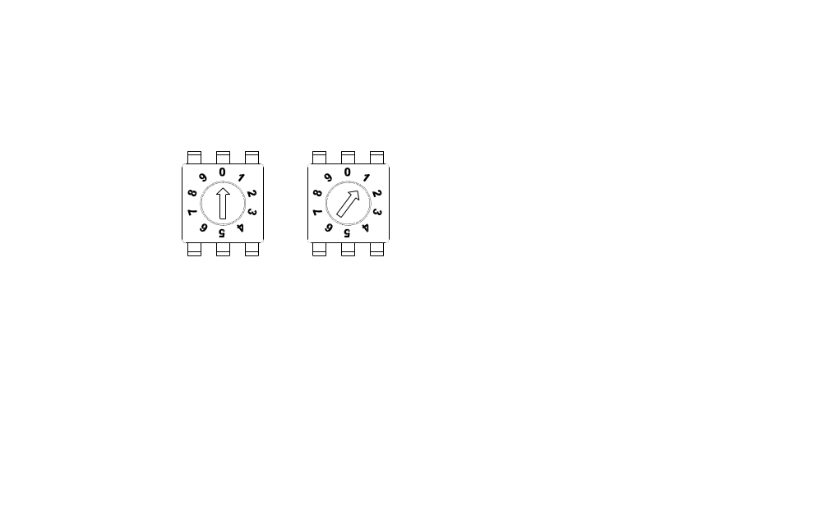
decimal single digit
- 16 Pin Connector for LAN/WAN
The LAN/WAN cable (shown as the figure below) is shipped with IP high speed dome. Please find it in the accessory bag.
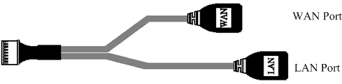
- 22 Pin Connector
A 50cm data cable (shown as the figure below) is shipped with IP high speed dome. Please find it in the accessory bag.
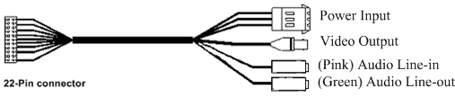
Power Input
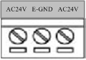
PIN | NAME | DESCRIPTION
1 | AC24V | AC 24V of Power Input
2 | E-GND | E-Ground Pin of Power Input
3 | AC24V | AC 24V of Power Input

- Cable Wiring
Users may meed to do cable wiring when connecting alarm input and output devices. The table follows will illustrate the way to wire cords into the connector housing(shown in the flgures below).
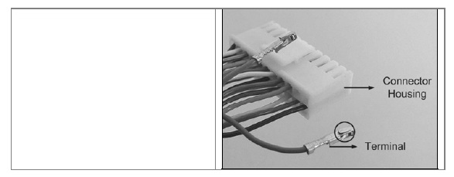
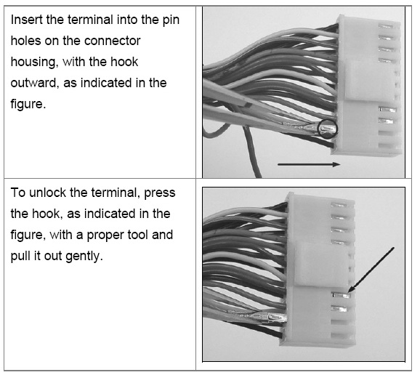

The alarm pins are serviceable for connecting alarm input and output devices, such as alarm sensors, sirens or flashing light with the surveillance system. The table shown as follows lists the definition of alarm pins on the 22-pin connector.
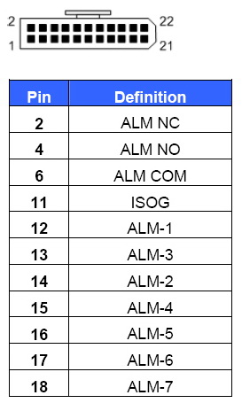

1.3 Mounting the IP High Speed Dome
Generally, there are three kinds of ceiling mounting methods: surface mount, in-ceiling mount, and mounting with straight tube. The surface mounting kit is shipped with IP high speed dome. For more detailed information, please refer to Appendix A.
Surface ceiling mount
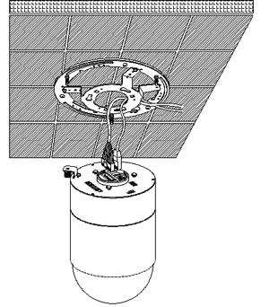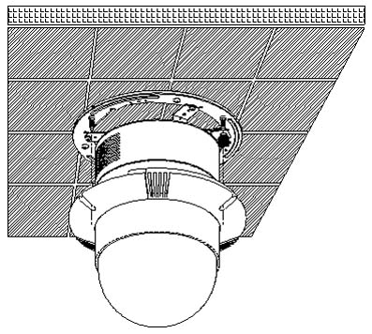
(cables exposed)

1.4 Basic Connections
Follow the procedures below to connect the IP high speed dome to the respective apparatuses.

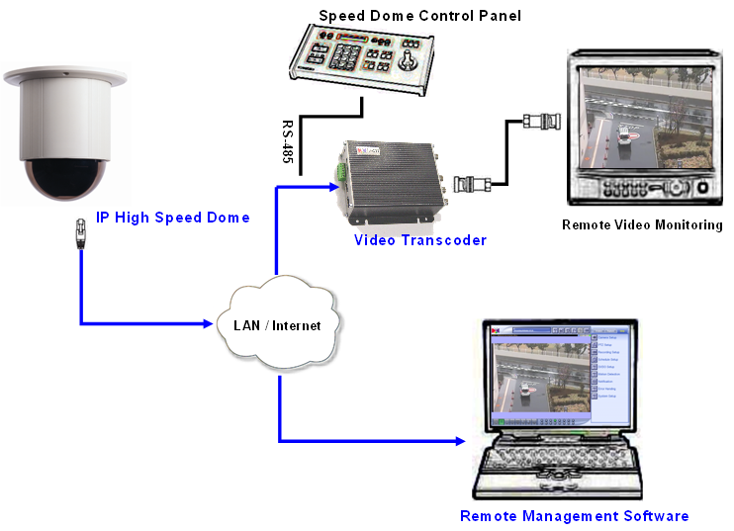

Quick Tour


This section guides you with a quick tour on IP high speed dome.

2.1 Configure the IP High Speed Dome
2.1.1 Make sure network environment
Default IP of IP high speed dome is 192.168.0.100. Please make sure IP high speed dome and your PC are on the same network segment before running the installation.

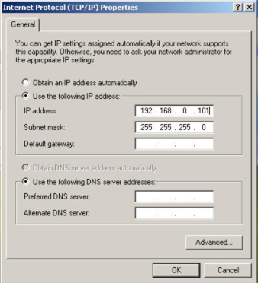
Please set the settings as below.

IP address: 192.168. 0.xxx
Subnet mask: 255.255.255. 0
(NOTE: xxx should be a number from 1 to 254, but 100 is excepted.)

    - Open Internet Explorer with IP address
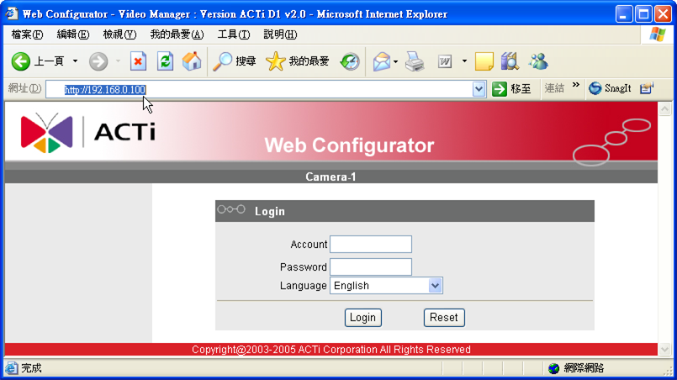

 | NOTE: If your web browser is earlier than IE6, then download IE6 is recommended.
 | NOTE: The IP high speed dome default IP address is set to 192.168.0.100

    - Login with default administrator’s account & password
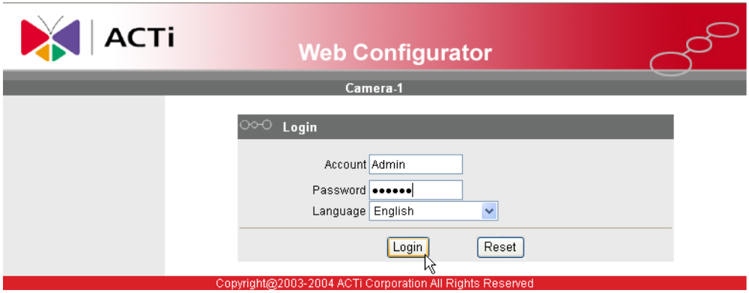

NOTE: Default administrator account is set to Admin, password is set to 123456, and click button.

    - Preview the video

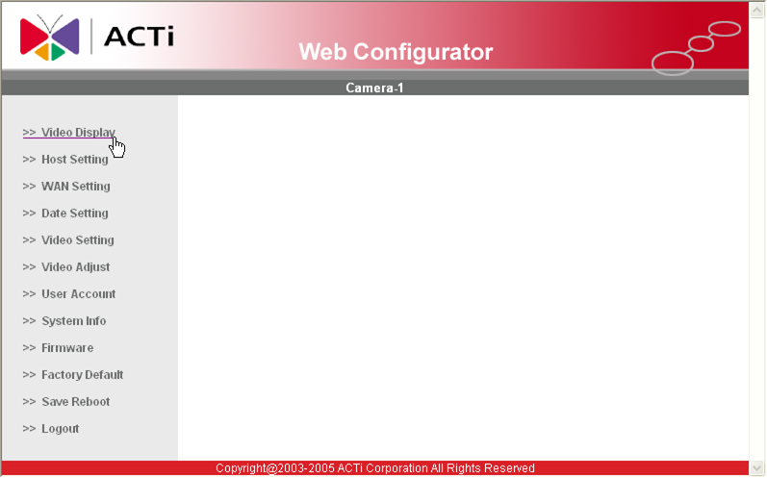

NOTE: In your Client PC, please make sure the setting of Network Connections Type is set to Auto Negotation, since IP high speed dome follows MII standard. Otherwise, you might not see the live image.

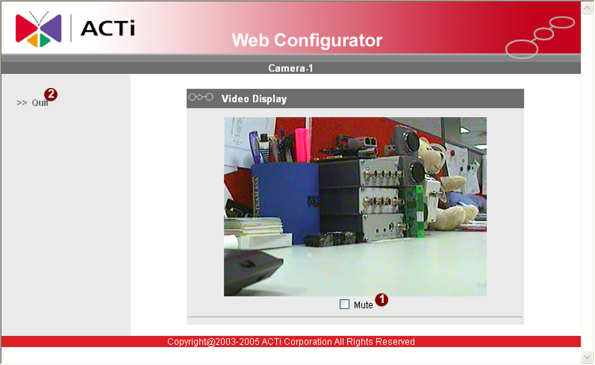

2.15 Set the new IP address

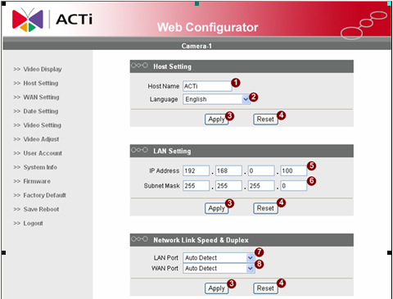

*Host Name : Enter in the domain name, Default Host Name is ACTi.
*Language : Language setting for Web Configurator after Save Reboot. Default setting is English.
*IP Address : The IP address of the LAN interface. The default IP address is 192.168.0.100.
*Subnet Mask : The subnet mask of the LAN interface.The default subnet mask is 255.255.255.0
*Click button

NOTE: Check with your MIS department, if Client PC and IP high speed dome are setting in different VLANs, please connect to WAN port.

NOTE: In your Client PC, please make sure the setting of Network Connections Type is set to Auto Negotation, since IP high speed dome follows MII standard. Otherwise, you might not see the live image.

 | IMPORTANT: After the IP address is changed, please record this IP address. There is no way to connect to the IP high speed dome if user forgets the new IP address.

    - Check Default Video Setting

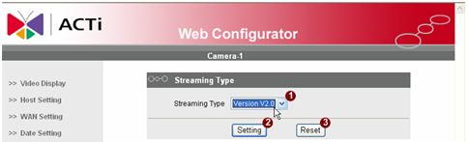

The streaming type [Version 1.0] – without audio function
The streaming type [Version 2.0] – with audio function

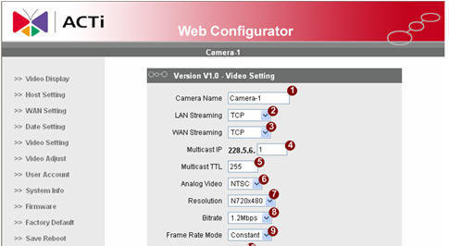

NOTE: Please make sure the TV Input (NTSC / PAL) is meet your requirement, and click button.

    - Click Save Reboot to restore all settings and please wait about 30 seconds for system reboot.

